Objective Questions

1. **Are there any tables with duplicate or missing null values? If so, how would you handle them?**

we can conclude that **duplicate and NULL values are not present** because the **DDL itself enforces data integrity**.

**Justification Based on Schema Design**

* **Primary Keys** ensure uniqueness
  + users.id
  + photos.id
  + comments.id
  + Composite keys in likes, follows, photo_tags
* **UNIQUE constraints** prevent duplicates
  + users.username
  + tags.tag_name
* **NOT NULL constraints** prevent missing values
  + All foreign keys
  + Mandatory descriptive fields (e.g., image_url, comment_text)
* **Foreign Key constraints** enforce referential integrity
  + Prevent orphan records
  + Ensure valid relationships
* **Composite Primary Keys**
  + Prevent duplicate likes and duplicate follow relationships

No duplicate or NULL values exist in the database because the schema enforces strict data integrity through primary keys, composite keys, UNIQUE constraints, NOT NULL constraints, and foreign key relationships. These constraints ensure that invalid or duplicate records cannot be inserted at the database level.

1. **What is the distribution of user activity levels (e.g., number of posts, likes, comments) across the user base?**

SELECT

u.id,

u.username,

COUNT(DISTINCT p.id) AS posts,

COUNT(DISTINCT l.photo_id) AS likes,

COUNT(DISTINCT c.id) AS comments

FROM users u

LEFT JOIN photos p ON u.id = p.user_id

LEFT JOIN likes l ON u.id = l.user_id

LEFT JOIN comments c ON u.id = c.user_id

GROUP BY u.id, u.username

ORDER BY posts desc, likes desc, comments DESC;

**Output :**

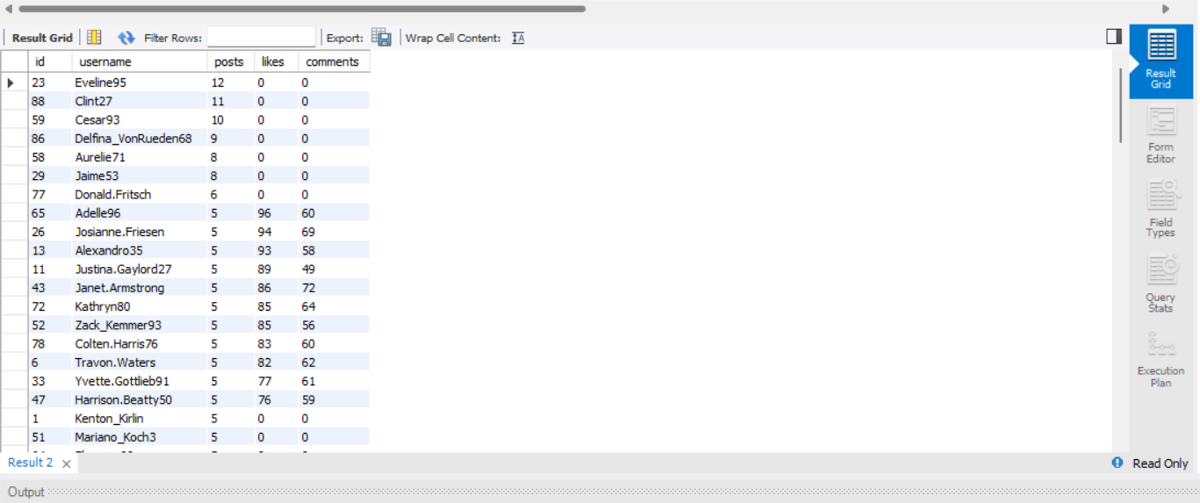

|  |  |  |  |  |
| --- | --- | --- | --- | --- |
| 23 | Eveline95 | 12 | 0 | 0 |
| 88 | Clint27 | 11 | 0 | 0 |
| 59 | Cesar93 | 10 | 0 | 0 |
| 86 | Delfina_VonRueden68 | 9 | 0 | 0 |
| 58 | Aurelie71 | 8 | 0 | 0 |
| 29 | Jaime53 | 8 | 0 | 0 |
| 77 | Donald.Fritsch | 6 | 0 | 0 |
| 65 | Adelle96 | 5 | 96 | 60 |
| 26 | Josianne.Friesen | 5 | 94 | 69 |
| 13 | Alexandro35 | 5 | 93 | 58 |
| 11 | Justina.Gaylord27 | 5 | 89 | 49 |
| 43 | Janet.Armstrong | 5 | 86 | 72 |
| 72 | Kathryn80 | 5 | 85 | 64 |
| 52 | Zack_Kemmer93 | 5 | 85 | 56 |
| 78 | Colten.Harris76 | 5 | 83 | 60 |
| 6 | Travon.Waters | 5 | 82 | 62 |
| 33 | Yvette.Gottlieb91 | 5 | 77 | 61 |
| 47 | Harrison.Beatty50 | 5 | 76 | 59 |
| 1 | Kenton_Kirlin | 5 | 0 | 0 |
| 51 | Mariano_Koch3 | 5 | 0 | 0 |
| 64 | Florence99 | 5 | 0 | 0 |
| 16 | Annalise.McKenzie16 | 4 | 103 | 52 |
| 2 | Andre_Purdy85 | 4 | 94 | 66 |
| 87 | Rick29 | 4 | 92 | 74 |
| 32 | Irwin.Larson | 4 | 91 | 56 |
| 46 | Malinda_Streich | 4 | 88 | 68 |
| 44 | Seth46 | 4 | 86 | 60 |
| 9 | Gus93 | 4 | 85 | 60 |
| 15 | Billy52 | 4 | 84 | 77 |
| 63 | Elenor88 | 4 | 83 | 80 |
| 3 | Harley_Lind18 | 4 | 79 | 67 |
| 8 | Tabitha_Schamberger11 | 4 | 79 | 61 |
| 12 | Dereck65 | 4 | 77 | 68 |
| 28 | Dario77 | 4 | 77 | 59 |
| 96 | Keenan.Schamberger60 | 3 | 98 | 75 |
| 4 | Arely_Bogan63 | 3 | 93 | 64 |
| 92 | Frederik_Rice | 3 | 91 | 61 |
| 10 | Presley_McClure | 3 | 87 | 63 |
| 42 | Maya.Farrell | 3 | 87 | 54 |
| 67 | Emilio_Bernier52 | 3 | 86 | 76 |
| 50 | Gerard79 | 3 | 81 | 69 |
| 17 | Norbert_Carroll35 | 3 | 78 | 83 |
| 99 | Alek_Watsica | 3 | 74 | 68 |
| 35 | Lennie_Hartmann40 | 2 | 92 | 67 |
| 93 | Willie_Leuschke | 2 | 91 | 63 |
| 19 | Hailee26 | 2 | 90 | 60 |
| 62 | Ressie_Stanton46 | 2 | 88 | 58 |
| 85 | Milford_Gleichner42 | 2 | 87 | 57 |
| 60 | Sam52 | 2 | 86 | 72 |
| 95 | Nicole71 | 2 | 86 | 68 |
| 38 | Jordyn.Jacobson2 | 2 | 85 | 58 |
| 82 | Aracely.Johnston98 | 2 | 84 | 67 |
| 100 | Javonte83 | 2 | 82 | 70 |
| 30 | Kaley9 | 2 | 81 | 65 |
| 84 | Alysa22 | 2 | 75 | 76 |
| 97 | Tomas.Beatty93 | 2 | 69 | 68 |
| 69 | Karley_Bosco | 1 | 97 | 69 |
| 22 | Kenneth64 | 1 | 91 | 67 |
| 39 | Kelsi26 | 1 | 89 | 67 |
| 70 | Erick5 | 1 | 88 | 69 |
| 31 | Aiyana_Hoeger | 1 | 88 | 66 |
| 20 | Delpha.Kihn | 1 | 87 | 67 |
| 73 | Jaylan.Lakin | 1 | 86 | 63 |
| 40 | Rafael.Hickle2 | 1 | 85 | 68 |
| 94 | Damon35 | 1 | 84 | 68 |
| 37 | Yazmin_Mills95 | 1 | 84 | 63 |
| 61 | Jayson65 | 1 | 83 | 58 |
| 18 | Odessa2 | 1 | 82 | 53 |
| 56 | Peter.Stehr0 | 1 | 81 | 68 |
| 27 | Darwin29 | 1 | 79 | 67 |
| 55 | Meggie_Doyle | 1 | 78 | 66 |
| 79 | Katarina.Dibbert | 1 | 75 | 68 |
| 48 | Granville_Kutch | 1 | 75 | 55 |
| 98 | Imani_Nicolas17 | 1 | 74 | 65 |
| 71 | Nia_Haag | 0 | 257 | 257 |
| 41 | Mckenna17 | 0 | 257 | 257 |
| 75 | Leslie67 | 0 | 257 | 257 |
| 5 | Aniya_Hackett | 0 | 257 | 257 |
| 66 | Mike.Auer39 | 0 | 257 | 257 |
| 36 | Ollie_Ledner37 | 0 | 257 | 257 |
| 57 | Julien_Schmidt | 0 | 257 | 257 |
| 54 | Duane60 | 0 | 257 | 257 |
| 91 | Bethany20 | 0 | 257 | 257 |
| 14 | Jaclyn81 | 0 | 257 | 257 |
| 76 | Janelle.Nikolaus81 | 0 | 257 | 257 |
| 24 | Maxwell.Halvorson | 0 | 257 | 257 |
| 21 | Rocio33 | 0 | 257 | 257 |
| 25 | Tierra.Trantow | 0 | 0 | 0 |
| 89 | Jessyca_West | 0 | 0 | 0 |
| 68 | Franco_Keebler64 | 0 | 0 | 0 |
| 83 | Bartholome.Bernhard | 0 | 0 | 0 |
| 49 | Morgan.Kassulke | 0 | 0 | 0 |
| 7 | Kasandra_Homenick | 0 | 0 | 0 |
| 45 | David.Osinski47 | 0 | 0 | 0 |
| 74 | Hulda.Macejkovic | 0 | 0 | 0 |
| 53 | Linnea59 | 0 | 0 | 0 |
| 80 | Darby_Herzog | 0 | 0 | 0 |
| 81 | Esther.Zulauf61 | 0 | 0 | 0 |
| 34 | Pearl7 | 0 | 0 | 0 |
| 90 | Esmeralda.Mraz57 | 0 | 0 | 0 |

1. **Calculate the average number of tags per post (photo_tags and photos tables).**

SELECT

ROUND(AVG(tag_count), 2) AS avg_tags_per_post

FROM (

SELECT

p.id AS photo_id,

COUNT(pt.tag_id) AS tag_count

FROM photos p

LEFT JOIN photo_tags pt

ON p.id = pt.photo_id

GROUP BY p.id

) t;

**Output :**

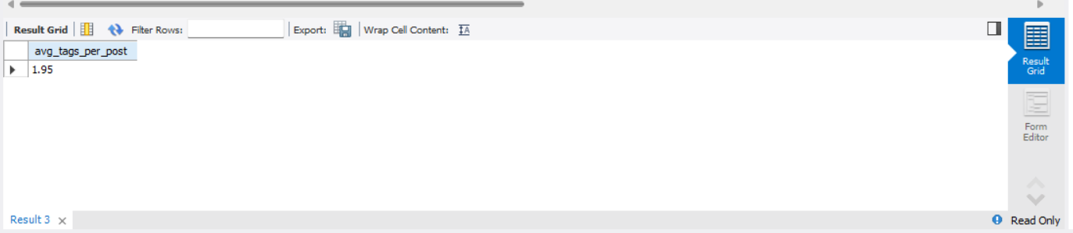

1. **Identify the top users with the highest engagement rates (likes, comments) on their posts and rank them.**

WITH user_engagement AS (

SELECT

p.user_id,

COUNT(DISTINCT l.user_id) AS total_likes,

COUNT(DISTINCT c.id) AS total_comments

FROM photos p

LEFT JOIN likes l

ON p.id = l.photo_id

LEFT JOIN comments c

ON p.id = c.photo_id

GROUP BY p.user_id

)

SELECT

u.id,

u.username,

ue.total_likes,

ue.total_comments,

(ue.total_likes + ue.total_comments) AS engagement_score,

RANK() OVER (

ORDER BY (ue.total_likes + ue.total_comments) DESC

) AS engagement_rank

FROM user_engagement ue

JOIN users u

ON ue.user_id = u.id

ORDER BY engagement_rank;

**Output :**

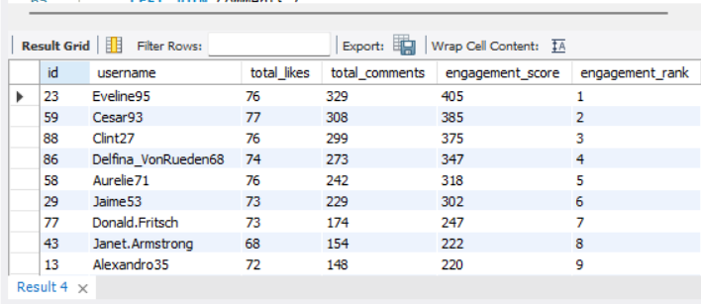

|  |  |  |  |  |  |
| --- | --- | --- | --- | --- | --- |
| id | username | total_likes | total_comments | engagement_score | engagement_rank |
| 23 | Eveline95 | 76 | 329 | 405 | 1 |
| 59 | Cesar93 | 77 | 308 | 385 | 2 |
| 88 | Clint27 | 76 | 299 | 375 | 3 |
| 86 | Delfina_VonRueden68 | 74 | 273 | 347 | 4 |
| 58 | Aurelie71 | 76 | 242 | 318 | 5 |
| 29 | Jaime53 | 73 | 229 | 302 | 6 |
| 77 | Donald.Fritsch | 73 | 174 | 247 | 7 |
| 43 | Janet.Armstrong | 68 | 154 | 222 | 8 |
| 13 | Alexandro35 | 72 | 148 | 220 | 9 |
| 52 | Zack_Kemmer93 | 68 | 151 | 219 | 10 |
| 11 | Justina.Gaylord27 | 69 | 147 | 216 | 11 |
| 65 | Adelle96 | 72 | 142 | 214 | 12 |
| 64 | Florence99 | 69 | 145 | 214 | 12 |
| 72 | Kathryn80 | 64 | 148 | 212 | 14 |
| 33 | Yvette.Gottlieb91 | 69 | 141 | 210 | 15 |
| 78 | Colten.Harris76 | 66 | 143 | 209 | 16 |
| 1 | Kenton_Kirlin | 67 | 142 | 209 | 16 |
| 6 | Travon.Waters | 69 | 139 | 208 | 18 |
| 51 | Mariano_Koch3 | 66 | 142 | 208 | 18 |
| 47 | Harrison.Beatty50 | 60 | 146 | 206 | 20 |
| 26 | Josianne.Friesen | 65 | 141 | 206 | 20 |
| 87 | Rick29 | 65 | 132 | 197 | 22 |
| 9 | Gus93 | 64 | 126 | 190 | 23 |
| 16 | Annalise.McKenzie16 | 64 | 126 | 190 | 23 |
| 63 | Elenor88 | 64 | 123 | 187 | 25 |
| 44 | Seth46 | 67 | 118 | 185 | 26 |
| 12 | Dereck65 | 66 | 117 | 183 | 27 |
| 46 | Malinda_Streich | 61 | 121 | 182 | 28 |
| 2 | Andre_Purdy85 | 62 | 119 | 181 | 29 |
| 32 | Irwin.Larson | 62 | 118 | 180 | 30 |
| 8 | Tabitha_Schamberger11 | 61 | 119 | 180 | 30 |
| 3 | Harley_Lind18 | 62 | 117 | 179 | 32 |
| 15 | Billy52 | 61 | 115 | 176 | 33 |
| 28 | Dario77 | 62 | 113 | 175 | 34 |
| 96 | Keenan.Schamberger60 | 56 | 98 | 154 | 35 |
| 10 | Presley_McClure | 57 | 90 | 147 | 36 |
| 50 | Gerard79 | 58 | 88 | 146 | 37 |
| 42 | Maya.Farrell | 57 | 87 | 144 | 38 |
| 17 | Norbert_Carroll35 | 59 | 83 | 142 | 39 |
| 92 | Frederik_Rice | 50 | 92 | 142 | 39 |
| 67 | Emilio_Bernier52 | 53 | 87 | 140 | 41 |
| 4 | Arely_Bogan63 | 61 | 77 | 138 | 42 |
| 99 | Alek_Watsica | 53 | 81 | 134 | 43 |
| 62 | Ressie_Stanton46 | 50 | 62 | 112 | 44 |
| 82 | Aracely.Johnston98 | 50 | 61 | 111 | 45 |
| 84 | Alysa22 | 54 | 55 | 109 | 46 |
| 100 | Javonte83 | 53 | 53 | 106 | 47 |
| 19 | Hailee26 | 49 | 56 | 105 | 48 |
| 38 | Jordyn.Jacobson2 | 45 | 60 | 105 | 48 |
| 93 | Willie_Leuschke | 48 | 57 | 105 | 48 |
| 35 | Lennie_Hartmann40 | 51 | 53 | 104 | 51 |
| 30 | Kaley9 | 44 | 59 | 103 | 52 |
| 95 | Nicole71 | 46 | 55 | 101 | 53 |
| 60 | Sam52 | 43 | 58 | 101 | 53 |
| 85 | Milford_Gleichner42 | 46 | 51 | 97 | 55 |
| 97 | Tomas.Beatty93 | 41 | 47 | 88 | 56 |
| 55 | Meggie_Doyle | 41 | 34 | 75 | 57 |
| 73 | Jaylan.Lakin | 38 | 35 | 73 | 58 |
| 48 | Granville_Kutch | 37 | 34 | 71 | 59 |
| 22 | Kenneth64 | 39 | 31 | 70 | 60 |
| 69 | Karley_Bosco | 36 | 32 | 68 | 61 |
| 94 | Damon35 | 40 | 28 | 68 | 61 |
| 18 | Odessa2 | 36 | 31 | 67 | 63 |
| 39 | Kelsi26 | 39 | 27 | 66 | 64 |
| 61 | Jayson65 | 38 | 28 | 66 | 64 |
| 20 | Delpha.Kihn | 41 | 24 | 65 | 66 |
| 70 | Erick5 | 36 | 29 | 65 | 66 |
| 37 | Yazmin_Mills95 | 39 | 26 | 65 | 66 |
| 27 | Darwin29 | 35 | 29 | 64 | 69 |
| 31 | Aiyana_Hoeger | 28 | 35 | 63 | 70 |
| 56 | Peter.Stehr0 | 33 | 28 | 61 | 71 |
| 40 | Rafael.Hickle2 | 33 | 26 | 59 | 72 |
| 79 | Katarina.Dibbert | 29 | 30 | 59 | 72 |
| 98 | Imani_Nicolas17 | 34 | 24 | 58 | 74 |

1. **Which users have the highest number of followers and followings?**

-- Highest by Followers --

with Highest_Followers as(SELECT

u.username,

COUNT(f.follower_id) AS followers,

rank() over(order by COUNT(f.follower_id) desc) as rnk

FROM users u

LEFT JOIN follows f ON u.id = f.followee_id

GROUP BY u.username

)

select username ,followers

from Highest_Followers where rnk = 1 ;

**Output :**

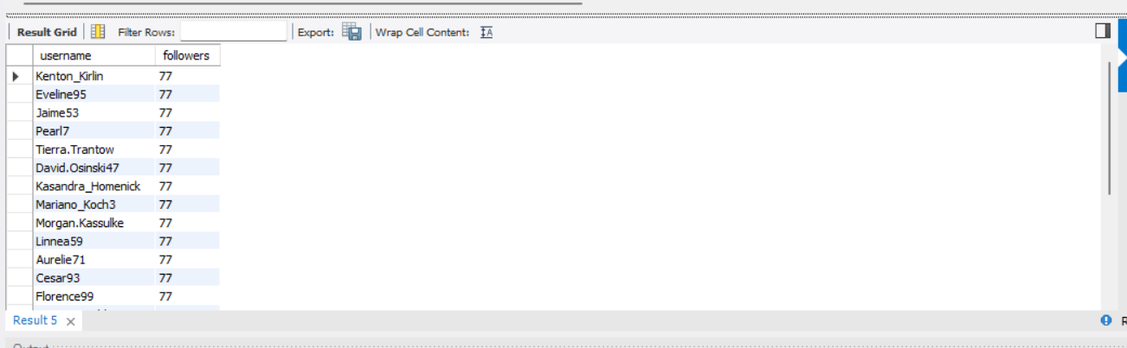

|  |  |
| --- | --- |
| Username | followers |
| Kenton_Kirlin | 77 |
| Eveline95 | 77 |
| Jaime53 | 77 |
| Pearl7 | 77 |
| Tierra.Trantow | 77 |
| David.Osinski47 | 77 |
| Kasandra_Homenick | 77 |
| Mariano_Koch3 | 77 |
| Morgan.Kassulke | 77 |
| Linnea59 | 77 |
| Aurelie71 | 77 |
| Cesar93 | 77 |
| Florence99 | 77 |
| Franco_Keebler64 | 77 |
| Hulda.Macejkovic | 77 |
| Clint27 | 77 |
| Donald.Fritsch | 77 |
| Darby_Herzog | 77 |
| Esther.Zulauf61 | 77 |
| Bartholome.Bernhard | 77 |
| Delfina_VonRueden68 | 77 |
| Jessyca_West | 77 |
| Esmeralda.Mraz57 | 77 |

-- Highest by Following --

with Highest_following as (SELECT

u.username,

COUNT(f.followee_id) AS following,

rank() Over(Order by COUNT(f.followee_id) desc ) as rnk

FROM users u

LEFT JOIN follows f ON u.id = f.follower_id

GROUP BY u.id, u.username

)

Select username ,

following

from Highest_following

where rnk = 1;

**Output :**

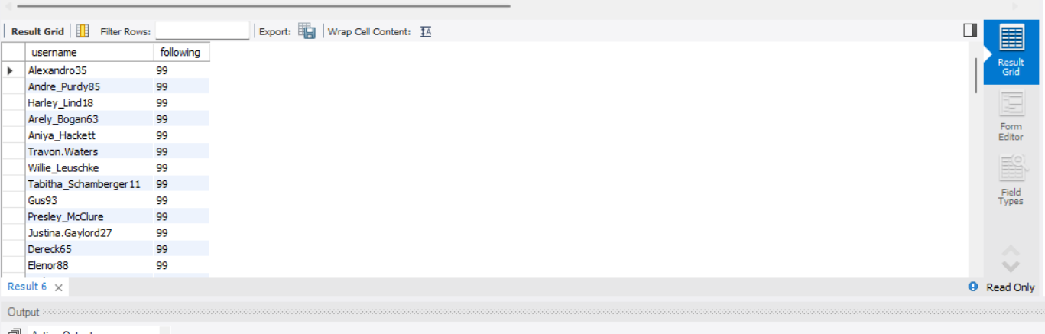

|  |  |
| --- | --- |
| Username | following |
| Alexandro35 | 99 |
| Andre_Purdy85 | 99 |
| Harley_Lind18 | 99 |
| Arely_Bogan63 | 99 |
| Aniya_Hackett | 99 |
| Travon.Waters | 99 |
| Willie_Leuschke | 99 |
| Tabitha_Schamberger11 | 99 |
| Gus93 | 99 |
| Presley_McClure | 99 |
| Justina.Gaylord27 | 99 |
| Dereck65 | 99 |
| Elenor88 | 99 |
| Jaclyn81 | 99 |
| Billy52 | 99 |
| Annalise.McKenzie16 | 99 |
| Norbert_Carroll35 | 99 |
| Odessa2 | 99 |
| Hailee26 | 99 |
| Delpha.Kihn | 99 |
| Rocio33 | 99 |
| Kenneth64 | 99 |
| Damon35 | 99 |
| Maxwell.Halvorson | 99 |
| Nicole71 | 99 |
| Josianne.Friesen | 99 |
| Darwin29 | 99 |
| Dario77 | 99 |
| Keenan.Schamberger60 | 99 |
| Kaley9 | 99 |
| Aiyana_Hoeger | 99 |
| Irwin.Larson | 99 |
| Yvette.Gottlieb91 | 99 |
| Tomas.Beatty93 | 99 |
| Lennie_Hartmann40 | 99 |
| Ollie_Ledner37 | 99 |
| Yazmin_Mills95 | 99 |
| Jordyn.Jacobson2 | 99 |
| Kelsi26 | 99 |
| Rafael.Hickle2 | 99 |
| Mckenna17 | 99 |
| Maya.Farrell | 99 |
| Janet.Armstrong | 99 |
| Seth46 | 99 |
| Imani_Nicolas17 | 99 |
| Malinda_Streich | 99 |
| Harrison.Beatty50 | 99 |
| Granville_Kutch | 99 |
| Alek_Watsica | 99 |
| Gerard79 | 99 |
| Javonte83 | 99 |
| Zack_Kemmer93 | 99 |
| Duane60 | 99 |
| Meggie_Doyle | 99 |
| Peter.Stehr0 | 99 |
| Julien_Schmidt | 99 |
| Sam52 | 99 |
| Jayson65 | 99 |
| Ressie_Stanton46 | 99 |
| Adelle96 | 99 |
| Mike.Auer39 | 99 |
| Emilio_Bernier52 | 99 |
| Karley_Bosco | 99 |
| Erick5 | 99 |
| Nia_Haag | 99 |
| Kathryn80 | 99 |
| Jaylan.Lakin | 99 |
| Leslie67 | 99 |
| Janelle.Nikolaus81 | 99 |
| Colten.Harris76 | 99 |
| Katarina.Dibbert | 99 |
| Aracely.Johnston98 | 99 |
| Alysa22 | 99 |
| Milford_Gleichner42 | 99 |
| Rick29 | 99 |
| Bethany20 | 99 |
| Frederik_Rice | 99 |

1. **Calculate the average engagement rate (likes, comments) per post for each user.**

WITH user_post_stats AS (

SELECT

p.user_id,

COUNT(DISTINCT p.id) AS total_posts,

COUNT(DISTINCT l.user_id) AS total_likes,

COUNT(DISTINCT c.id) AS total_comments

FROM photos p

LEFT JOIN likes l

ON p.id = l.photo_id

LEFT JOIN comments c

ON p.id = c.photo_id

GROUP BY p.user_id

)

SELECT

u.id,

u.username,

ups.total_posts,

ups.total_likes,

ups.total_comments,

ROUND(

(ups.total_likes + ups.total_comments) / ups.total_posts,

2

) AS avg_engagement_per_post

FROM user_post_stats ups

JOIN users u

ON ups.user_id = u.id

ORDER BY avg_engagement_per_post DESC;

**Output :**

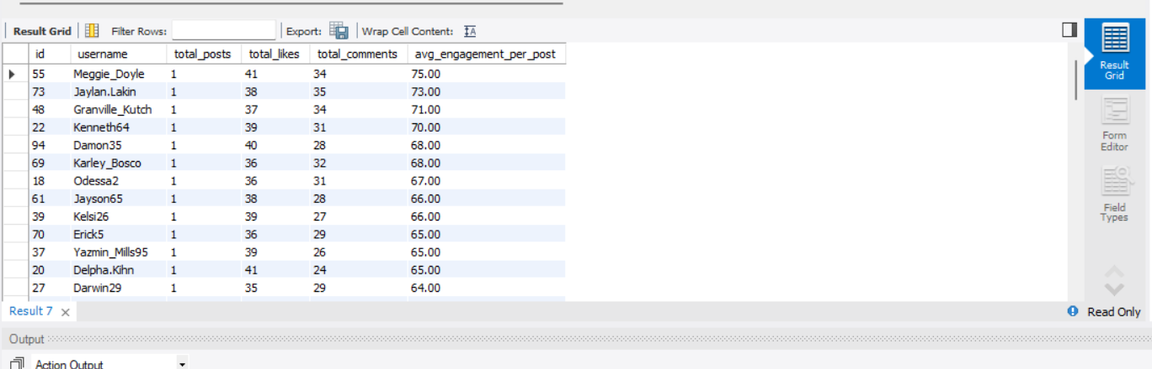

|  |  |  |  |  |  |
| --- | --- | --- | --- | --- | --- |
| Id | Username | Total_post | Total_likes | Total_comments | avg_engagement_per_post |
| 55 | Meggie_Doyle | 1 | 41 | 34 | 75.00 |
| 73 | Jaylan.Lakin | 1 | 38 | 35 | 73.00 |
| 48 | Granville_Kutch | 1 | 37 | 34 | 71.00 |
| 22 | Kenneth64 | 1 | 39 | 31 | 70.00 |
| 94 | Damon35 | 1 | 40 | 28 | 68.00 |
| 69 | Karley_Bosco | 1 | 36 | 32 | 68.00 |
| 18 | Odessa2 | 1 | 36 | 31 | 67.00 |
| 61 | Jayson65 | 1 | 38 | 28 | 66.00 |
| 39 | Kelsi26 | 1 | 39 | 27 | 66.00 |
| 70 | Erick5 | 1 | 36 | 29 | 65.00 |
| 37 | Yazmin_Mills95 | 1 | 39 | 26 | 65.00 |
| 20 | Delpha.Kihn | 1 | 41 | 24 | 65.00 |
| 27 | Darwin29 | 1 | 35 | 29 | 64.00 |
| 31 | Aiyana_Hoeger | 1 | 28 | 35 | 63.00 |
| 56 | Peter.Stehr0 | 1 | 33 | 28 | 61.00 |
| 79 | Katarina.Dibbert | 1 | 29 | 30 | 59.00 |
| 40 | Rafael.Hickle2 | 1 | 33 | 26 | 59.00 |
| 98 | Imani_Nicolas17 | 1 | 34 | 24 | 58.00 |
| 62 | Ressie_Stanton46 | 2 | 50 | 62 | 56.00 |
| 82 | Aracely.Johnston98 | 2 | 50 | 61 | 55.50 |
| 84 | Alysa22 | 2 | 54 | 55 | 54.50 |
| 100 | Javonte83 | 2 | 53 | 53 | 53.00 |
| 93 | Willie_Leuschke | 2 | 48 | 57 | 52.50 |
| 19 | Hailee26 | 2 | 49 | 56 | 52.50 |
| 38 | Jordyn.Jacobson2 | 2 | 45 | 60 | 52.50 |
| 35 | Lennie_Hartmann40 | 2 | 51 | 53 | 52.00 |
| 30 | Kaley9 | 2 | 44 | 59 | 51.50 |
| 96 | Keenan.Schamberger60 | 3 | 56 | 98 | 51.33 |
| 60 | Sam52 | 2 | 43 | 58 | 50.50 |
| 95 | Nicole71 | 2 | 46 | 55 | 50.50 |
| 87 | Rick29 | 4 | 65 | 132 | 49.25 |
| 10 | Presley_McClure | 3 | 57 | 90 | 49.00 |
| 50 | Gerard79 | 3 | 58 | 88 | 48.67 |
| 85 | Milford_Gleichner42 | 2 | 46 | 51 | 48.50 |
| 42 | Maya.Farrell | 3 | 57 | 87 | 48.00 |
| 9 | Gus93 | 4 | 64 | 126 | 47.50 |
| 16 | Annalise.McKenzie16 | 4 | 64 | 126 | 47.50 |
| 17 | Norbert_Carroll35 | 3 | 59 | 83 | 47.33 |
| 92 | Frederik_Rice | 3 | 50 | 92 | 47.33 |
| 63 | Elenor88 | 4 | 64 | 123 | 46.75 |
| 67 | Emilio_Bernier52 | 3 | 53 | 87 | 46.67 |
| 44 | Seth46 | 4 | 67 | 118 | 46.25 |
| 4 | Arely_Bogan63 | 3 | 61 | 77 | 46.00 |
| 12 | Dereck65 | 4 | 66 | 117 | 45.75 |
| 46 | Malinda_Streich | 4 | 61 | 121 | 45.50 |
| 2 | Andre_Purdy85 | 4 | 62 | 119 | 45.25 |
| 8 | Tabitha_Schamberger11 | 4 | 61 | 119 | 45.00 |
| 32 | Irwin.Larson | 4 | 62 | 118 | 45.00 |
| 3 | Harley_Lind18 | 4 | 62 | 117 | 44.75 |
| 99 | Alek_Watsica | 3 | 53 | 81 | 44.67 |
| 43 | Janet.Armstrong | 5 | 68 | 154 | 44.40 |
| 15 | Billy52 | 4 | 61 | 115 | 44.00 |
| 13 | Alexandro35 | 5 | 72 | 148 | 44.00 |
| 97 | Tomas.Beatty93 | 2 | 41 | 47 | 44.00 |
| 52 | Zack_Kemmer93 | 5 | 68 | 151 | 43.80 |
| 28 | Dario77 | 4 | 62 | 113 | 43.75 |
| 11 | Justina.Gaylord27 | 5 | 69 | 147 | 43.20 |
| 64 | Florence99 | 5 | 69 | 145 | 42.80 |
| 65 | Adelle96 | 5 | 72 | 142 | 42.80 |
| 72 | Kathryn80 | 5 | 64 | 148 | 42.40 |
| 33 | Yvette.Gottlieb91 | 5 | 69 | 141 | 42.00 |
| 78 | Colten.Harris76 | 5 | 66 | 143 | 41.80 |
| 1 | Kenton_Kirlin | 5 | 67 | 142 | 41.80 |
| 6 | Travon.Waters | 5 | 69 | 139 | 41.60 |
| 51 | Mariano_Koch3 | 5 | 66 | 142 | 41.60 |
| 47 | Harrison.Beatty50 | 5 | 60 | 146 | 41.20 |
| 26 | Josianne.Friesen | 5 | 65 | 141 | 41.20 |
| 77 | Donald.Fritsch | 6 | 73 | 174 | 41.17 |
| 58 | Aurelie71 | 8 | 76 | 242 | 39.75 |
| 86 | Delfina_VonRueden68 | 9 | 74 | 273 | 38.56 |
| 59 | Cesar93 | 10 | 77 | 308 | 38.50 |
| 29 | Jaime53 | 8 | 73 | 229 | 37.75 |
| 88 | Clint27 | 11 | 76 | 299 | 34.09 |
| 23 | Eveline95 | 12 | 76 | 329 | 33.75 |

1. **Get the list of users who have never liked any post (users and likes tables)**

SELECT

u.id,

u.username

FROM users u

LEFT JOIN likes l

ON u.id = l.user_id

WHERE l.user_id IS NULL;

**Output :**

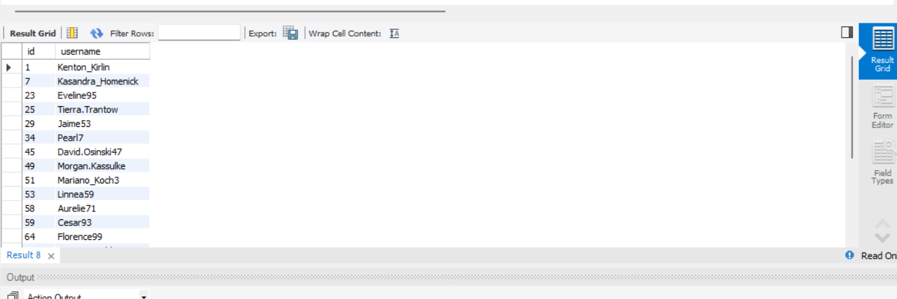

|  |  |
| --- | --- |
| Id | Username |
| 1 | Kenton_Kirlin |
| 7 | Kasandra_Homenick |
| 23 | Eveline95 |
| 25 | Tierra.Trantow |
| 29 | Jaime53 |
| 34 | Pearl7 |
| 45 | David.Osinski47 |
| 49 | Morgan.Kassulke |
| 51 | Mariano_Koch3 |
| 53 | Linnea59 |
| 58 | Aurelie71 |
| 59 | Cesar93 |
| 64 | Florence99 |
| 68 | Franco_Keebler64 |
| 74 | Hulda.Macejkovic |
| 77 | Donald.Fritsch |
| 80 | Darby_Herzog |
| 81 | Esther.Zulauf61 |
| 83 | Bartholome.Bernhard |
| 86 | Delfina_VonRueden68 |
| 88 | Clint27 |
| 89 | Jessyca_West |
| 90 | Esmeralda.Mraz57 |

1. **How can you leverage user-generated content (posts, hashtags, photo tags) to create more personalized and engaging ad campaigns?**

This question focuses on **using real user behavior captured in the database**—such as hashtags, likes, comments, and post engagement—to design **data-driven ad campaigns** instead of generic, brand-only promotions.  
In this project, we analyzed **hashtag-level engagement** to understand what type of content users actively interact with.

**Data Insights from Analysis**

**1. High-Engagement Hashtags (Quality over Quantity)**

From the **average engagement per post** analysis:

-- Top Hashtags by Average Engagement per Post

WITH hashtag_engagement AS (

SELECT

t.tag_name,

COUNT(DISTINCT p.id) AS total_posts,

COUNT(DISTINCT l.user_id) AS total_likes,

COUNT(DISTINCT c.id) AS total_comments

FROM tags t

JOIN photo_tags pt ON t.id = pt.tag_id

JOIN photos p ON pt.photo_id = p.id

LEFT JOIN likes l ON p.id = l.photo_id

LEFT JOIN comments c ON p.id = c.photo_id

GROUP BY t.tag_name

)

SELECT

tag_name,

ROUND((total_likes + total_comments) / total_posts, 2) AS avg_engagement_per_post

FROM hashtag_engagement

ORDER BY avg_engagement_per_post DESC

limit 5 ;

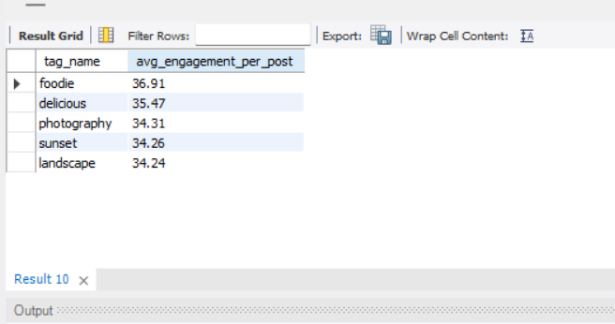

These hashtags generate **strong engagement per post**, making them ideal for **premium and niche ad targeting**.

**2. High-Volume Engagement Hashtags (Scale & Reach)**

From **total engagement distribution**:

* **smile (1802)**
* **beach (1293)**
* **party (1228)**
* **fun (1166)**

These hashtags attract **large audience interaction**, making them suitable for **mass-awareness campaigns**.

-- Engagement Distribution by Hashtag Theme

SELECT

t.tag_name,

COUNT(DISTINCT l.user_id) + COUNT(DISTINCT c.id) AS total_engagement

FROM tags t

JOIN photo_tags pt ON t.id = pt.tag_id

JOIN photos p ON pt.photo_id = p.id

LEFT JOIN likes l ON p.id = l.photo_id

LEFT JOIN comments c ON p.id = c.photo_id

GROUP BY t.tag_name

ORDER BY total_engagement DESC;

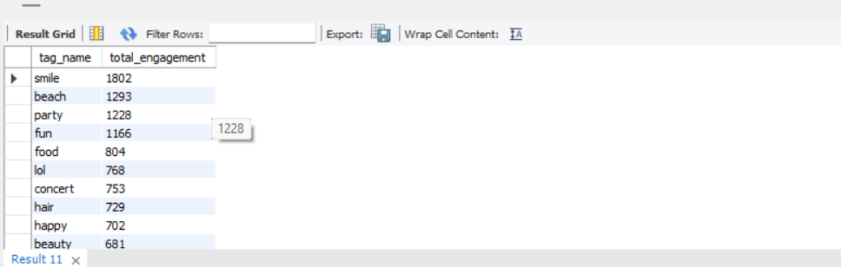

1. **Are there any correlations between user activity levels and specific content types (e.g., photos, videos, reels)? How can this information guide content creation and curation strategies?**

In this project, users were segmented into **High, Medium, Low, and Inactive activity groups** based on their posting and engagement behavior. Engagement was then analyzed across **content types (hashtags/themes)** to identify correlations between **activity level and content preference**.

**Key Observations from Charts & Data**

**1. Activity Level vs Overall Engagement**

* **High-activity users** show **significantly higher engagement (156.14)** compared to all other groups.
* **Inactive users** contribute **almost zero engagement**, confirming minimal platform value without intervention.
* This highlights that **user activity level strongly correlates with engagement volume**.

WITH user_activity AS (

SELECT

u.id,

COUNT(p.id) AS total_posts,

COUNT(DISTINCT l.user_id) + COUNT(DISTINCT c.id) AS total_engagement

FROM users u

LEFT JOIN photos p ON u.id = p.user_id

LEFT JOIN likes l ON p.id = l.photo_id

LEFT JOIN comments c ON p.id = c.photo_id

GROUP BY u.id

)

SELECT

CASE

WHEN total_posts >= 10 THEN 'High Activity'

WHEN total_posts BETWEEN 5 AND 9 THEN 'Medium Activity'

WHEN total_posts BETWEEN 1 AND 4 THEN 'Low Activity'

ELSE 'Inactive'

END AS activity_level,

ROUND(AVG(total_engagement), 2) AS avg_engagement

FROM user_activity

GROUP BY activity_level

ORDER BY avg_engagement DESC;

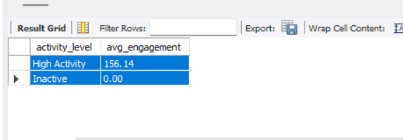

**2. Content Types Preferred by High-Activity Users**

* High-activity users engage more with **niche and quality-driven content**, such as:
  + *foodie, delicious, photography, sunset, landscape*
* These content types have **higher average engagement per post (33–37 range)**.
* This indicates that **engaged creators prefer visually rich and thematic content**.

WITH content_engagement AS (

SELECT

t.tag_name AS content_type,

COUNT(DISTINCT p.id) AS total_posts,

COUNT(DISTINCT l.user_id) + COUNT(DISTINCT c.id) AS total_engagement

FROM tags t

JOIN photo_tags pt ON t.id = pt.tag_id

JOIN photos p ON pt.photo_id = p.id

LEFT JOIN likes l ON p.id = l.photo_id

LEFT JOIN comments c ON p.id = c.photo_id

GROUP BY t.tag_name

)

SELECT

content_type,

ROUND(total_engagement / total_posts, 2) AS avg_engagement_per_post

FROM content_engagement

ORDER BY avg_engagement_per_post DESC

LIMIT 10;

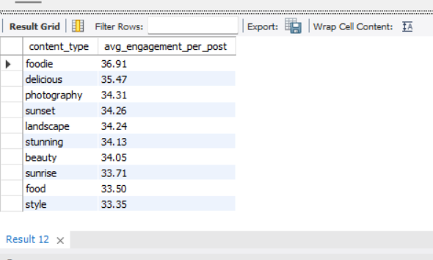

**3. Content Types Dominated by Low & Inactive Users (Stacked/Grouped Bar Chart)**

* **Low and Inactive users** mostly interact with **generic, emotion-based tags**, such as:
  + *smile, beach, fun, party, lol*
* Although total engagement counts are high, this is due to **volume**, not depth.
* These users rarely transition into **content creators**, remaining passive consumers.

-- Activity Level vs Preferred Content Type

WITH user_posts AS (

SELECT

u.id,

CASE

WHEN COUNT(p.id) >= 10 THEN 'High Activity'

WHEN COUNT(p.id) BETWEEN 5 AND 9 THEN 'Medium Activity'

WHEN COUNT(p.id) BETWEEN 1 AND 4 THEN 'Low Activity'

ELSE 'Inactive'

END AS activity_level

FROM users u

LEFT JOIN photos p ON u.id = p.user_id

GROUP BY u.id

)

SELECT

up.activity_level,

t.tag_name AS content_type,

COUNT(*) AS interactions

FROM user_posts up

JOIN likes l ON up.id = l.user_id

JOIN photo_tags pt ON l.photo_id = pt.photo_id

JOIN tags t ON pt.tag_id = t.id

GROUP BY up.activity_level, t.tag_name

ORDER BY interactions DESC;

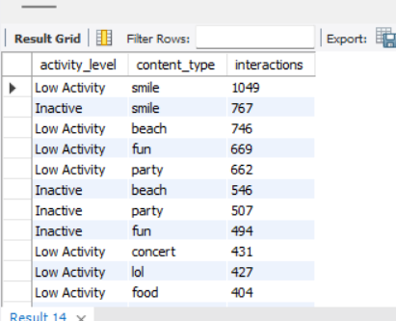

1. **Calculate the total number of likes, comments, and photo tags for each user.**

WITH user_photos AS (

SELECT

id AS photo_id,

user_id

FROM photos

),

likes_per_user AS (

SELECT

up.user_id,

COUNT(l.user_id) AS total_likes

FROM user_photos up

LEFT JOIN likes l

ON up.photo_id = l.photo_id

GROUP BY up.user_id

),

comments_per_user AS (

SELECT

up.user_id,

COUNT(c.id) AS total_comments

FROM user_photos up

LEFT JOIN comments c

ON up.photo_id = c.photo_id

GROUP BY up.user_id

),

tags_per_user AS (

SELECT

up.user_id,

COUNT(pt.tag_id) AS total_tags

FROM user_photos up

LEFT JOIN photo_tags pt

ON up.photo_id = pt.photo_id

GROUP BY up.user_id

)

SELECT

u.id,

u.username,

COALESCE(lu.total_likes, 0) AS total_likes,

COALESCE(cu.total_comments, 0) AS total_comments,

COALESCE(tu.total_tags, 0) AS total_photo_tags

FROM users u

LEFT JOIN likes_per_user lu ON u.id = lu.user_id

LEFT JOIN comments_per_user cu ON u.id = cu.user_id

LEFT JOIN tags_per_user tu ON u.id = tu.user_id

ORDER BY total_likes DESC ,total_comments DESC, total_photo_tags DESC;

**Output :**

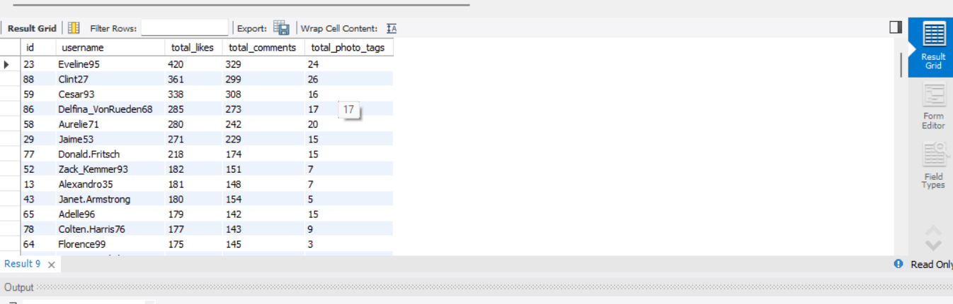

|  |  |  |  |  |
| --- | --- | --- | --- | --- |
| id | username | total_likes | total_comments | total_photo_tags |
| 23 | Eveline95 | 420 | 329 | 24 |
| 88 | Clint27 | 361 | 299 | 26 |
| 59 | Cesar93 | 338 | 308 | 16 |
| 86 | Delfina_VonRueden68 | 285 | 273 | 17 |
| 58 | Aurelie71 | 280 | 242 | 20 |
| 29 | Jaime53 | 271 | 229 | 15 |
| 77 | Donald.Fritsch | 218 | 174 | 15 |
| 52 | Zack_Kemmer93 | 182 | 151 | 7 |
| 13 | Alexandro35 | 181 | 148 | 7 |
| 43 | Janet.Armstrong | 180 | 154 | 5 |
| 65 | Adelle96 | 179 | 142 | 15 |
| 78 | Colten.Harris76 | 177 | 143 | 9 |
| 64 | Florence99 | 175 | 145 | 3 |
| 33 | Yvette.Gottlieb91 | 175 | 141 | 7 |
| 6 | Travon.Waters | 173 | 139 | 8 |
| 1 | Kenton_Kirlin | 168 | 142 | 18 |
| 26 | Josianne.Friesen | 168 | 141 | 11 |
| 11 | Justina.Gaylord27 | 166 | 147 | 12 |
| 51 | Mariano_Koch3 | 163 | 142 | 11 |
| 72 | Kathryn80 | 157 | 148 | 3 |
| 47 | Harrison.Beatty50 | 151 | 146 | 6 |
| 44 | Seth46 | 146 | 118 | 11 |
| 46 | Malinda_Streich | 145 | 121 | 9 |
| 87 | Rick29 | 140 | 132 | 10 |
| 32 | Irwin.Larson | 140 | 118 | 9 |
| 12 | Dereck65 | 140 | 117 | 2 |
| 28 | Dario77 | 139 | 113 | 5 |
| 16 | Annalise.McKenzie16 | 137 | 126 | 4 |
| 8 | Tabitha_Schamberger11 | 137 | 119 | 13 |
| 63 | Elenor88 | 135 | 123 | 9 |
| 3 | Harley_Lind18 | 132 | 117 | 7 |
| 9 | Gus93 | 130 | 126 | 11 |
| 15 | Billy52 | 129 | 115 | 4 |
| 2 | Andre_Purdy85 | 127 | 119 | 13 |
| 17 | Norbert_Carroll35 | 108 | 83 | 7 |
| 4 | Arely_Bogan63 | 106 | 77 | 2 |
| 10 | Presley_McClure | 105 | 90 | 10 |
| 42 | Maya.Farrell | 103 | 87 | 3 |
| 96 | Keenan.Schamberger60 | 99 | 98 | 6 |
| 92 | Frederik_Rice | 98 | 92 | 5 |
| 50 | Gerard79 | 98 | 88 | 10 |
| 67 | Emilio_Bernier52 | 97 | 87 | 3 |
| 99 | Alek_Watsica | 96 | 81 | 5 |
| 100 | Javonte83 | 77 | 53 | 3 |
| 84 | Alysa22 | 73 | 55 | 6 |
| 82 | Aracely.Johnston98 | 72 | 61 | 5 |
| 62 | Ressie_Stanton46 | 70 | 62 | 5 |
| 19 | Hailee26 | 69 | 56 | 7 |
| 35 | Lennie_Hartmann40 | 69 | 53 | 0 |
| 93 | Willie_Leuschke | 68 | 57 | 5 |
| 30 | Kaley9 | 65 | 59 | 9 |
| 95 | Nicole71 | 64 | 55 | 0 |
| 85 | Milford_Gleichner42 | 64 | 51 | 4 |
| 60 | Sam52 | 63 | 58 | 2 |
| 38 | Jordyn.Jacobson2 | 62 | 60 | 4 |
| 97 | Tomas.Beatty93 | 59 | 47 | 4 |
| 55 | Meggie_Doyle | 41 | 34 | 1 |
| 20 | Delpha.Kihn | 41 | 24 | 2 |
| 94 | Damon35 | 40 | 28 | 3 |
| 22 | Kenneth64 | 39 | 31 | 1 |
| 39 | Kelsi26 | 39 | 27 | 1 |
| 37 | Yazmin_Mills95 | 39 | 26 | 3 |
| 73 | Jaylan.Lakin | 38 | 35 | 0 |
| 61 | Jayson65 | 38 | 28 | 1 |
| 48 | Granville_Kutch | 37 | 34 | 4 |
| 69 | Karley_Bosco | 36 | 32 | 3 |
| 18 | Odessa2 | 36 | 31 | 1 |
| 70 | Erick5 | 36 | 29 | 2 |
| 27 | Darwin29 | 35 | 29 | 0 |
| 98 | Imani_Nicolas17 | 34 | 24 | 0 |
| 56 | Peter.Stehr0 | 33 | 28 | 1 |
| 40 | Rafael.Hickle2 | 33 | 26 | 4 |
| 79 | Katarina.Dibbert | 29 | 30 | 2 |
| 31 | Aiyana_Hoeger | 28 | 35 | 5 |
| 74 | Hulda.Macejkovic | 0 | 0 | 0 |
| 75 | Leslie67 | 0 | 0 | 0 |
| 41 | Mckenna17 | 0 | 0 | 0 |
| 71 | Nia_Haag | 0 | 0 | 0 |
| 68 | Franco_Keebler64 | 0 | 0 | 0 |
| 45 | David.Osinski47 | 0 | 0 | 0 |
| 80 | Darby_Herzog | 0 | 0 | 0 |
| 81 | Esther.Zulauf61 | 0 | 0 | 0 |
| 49 | Morgan.Kassulke | 0 | 0 | 0 |
| 83 | Bartholome.Bernhard | 0 | 0 | 0 |
| 57 | Julien_Schmidt | 0 | 0 | 0 |
| 54 | Duane60 | 0 | 0 | 0 |
| 36 | Ollie_Ledner37 | 0 | 0 | 0 |
| 53 | Linnea59 | 0 | 0 | 0 |
| 34 | Pearl7 | 0 | 0 | 0 |
| 89 | Jessyca_West | 0 | 0 | 0 |
| 90 | Esmeralda.Mraz57 | 0 | 0 | 0 |
| 91 | Bethany20 | 0 | 0 | 0 |
| 66 | Mike.Auer39 | 0 | 0 | 0 |
| 21 | Rocio33 | 0 | 0 | 0 |
| 5 | Aniya_Hackett | 0 | 0 | 0 |
| 25 | Tierra.Trantow | 0 | 0 | 0 |
| 24 | Maxwell.Halvorson | 0 | 0 | 0 |
| 14 | Jaclyn81 | 0 | 0 | 0 |
| 7 | Kasandra_Homenick | 0 | 0 | 0 |
| 76 | Janelle.Nikolaus81 | 0 | 0 | 0 |

1. **Rank users based on their total engagement (likes, comments, shares) over a month.**

WITH monthly_likes AS (

SELECT

p.user_id,

DATE_FORMAT(l.created_at, '%Y-%m') AS `year_month`,

COUNT(*) AS likes_count

FROM photos p

JOIN likes l

ON p.id = l.photo_id

GROUP BY

p.user_id,

DATE_FORMAT(l.created_at, '%Y-%m')

),

monthly_comments AS (

SELECT

p.user_id,

DATE_FORMAT(c.created_at, '%Y-%m') AS `year_month`,

COUNT(*) AS comments_count

FROM photos p

JOIN comments c

ON p.id = c.photo_id

GROUP BY

p.user_id,

DATE_FORMAT(c.created_at, '%Y-%m')

),

monthly_engagement AS (

SELECT

COALESCE(ml.user_id, mc.user_id) AS user_id,

COALESCE(ml.`year_month`, mc.`year_month`) AS `year_month`,

COALESCE(ml.likes_count, 0) AS likes,

COALESCE(mc.comments_count, 0) AS comments

FROM monthly_likes ml

LEFT JOIN monthly_comments mc

ON ml.user_id = mc.user_id

AND ml.`year_month` = mc.`year_month`

)

SELECT

u.id,

u.username,

me.`year_month`,

me.likes,

me.comments,

(me.likes + me.comments) AS total_engagement,

RANK() OVER (

PARTITION BY me.`year_month`

ORDER BY (me.likes + me.comments) DESC

) AS engagement_rank

FROM monthly_engagement me

JOIN users u

ON me.user_id = u.id

ORDER BY me.`year_month`, engagement_rank;

**Output :**

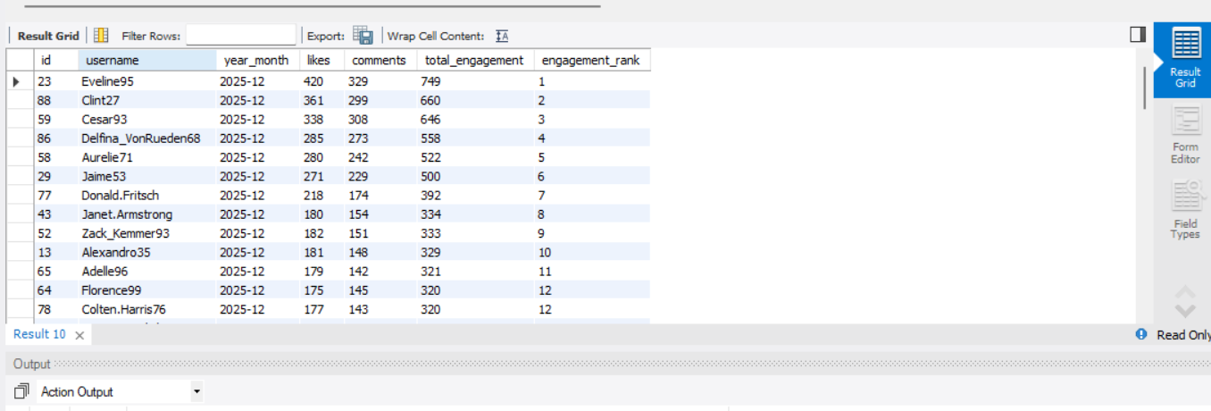

|  |  |  |  |  |  |  |
| --- | --- | --- | --- | --- | --- | --- |
| id | username | year_month | likes | comments | total_engagement | engagement_rank |
| 23 | Eveline95 | 2025-12 | 420 | 329 | 749 | 1 |
| 88 | Clint27 | 2025-12 | 361 | 299 | 660 | 2 |
| 59 | Cesar93 | 2025-12 | 338 | 308 | 646 | 3 |
| 86 | Delfina_VonRueden68 | 2025-12 | 285 | 273 | 558 | 4 |
| 58 | Aurelie71 | 2025-12 | 280 | 242 | 522 | 5 |
| 29 | Jaime53 | 2025-12 | 271 | 229 | 500 | 6 |
| 77 | Donald.Fritsch | 2025-12 | 218 | 174 | 392 | 7 |
| 43 | Janet.Armstrong | 2025-12 | 180 | 154 | 334 | 8 |
| 52 | Zack_Kemmer93 | 2025-12 | 182 | 151 | 333 | 9 |
| 13 | Alexandro35 | 2025-12 | 181 | 148 | 329 | 10 |
| 65 | Adelle96 | 2025-12 | 179 | 142 | 321 | 11 |
| 64 | Florence99 | 2025-12 | 175 | 145 | 320 | 12 |
| 78 | Colten.Harris76 | 2025-12 | 177 | 143 | 320 | 12 |
| 33 | Yvette.Gottlieb91 | 2025-12 | 175 | 141 | 316 | 14 |
| 11 | Justina.Gaylord27 | 2025-12 | 166 | 147 | 313 | 15 |
| 6 | Travon.Waters | 2025-12 | 173 | 139 | 312 | 16 |
| 1 | Kenton_Kirlin | 2025-12 | 168 | 142 | 310 | 17 |
| 26 | Josianne.Friesen | 2025-12 | 168 | 141 | 309 | 18 |
| 51 | Mariano_Koch3 | 2025-12 | 163 | 142 | 305 | 19 |
| 72 | Kathryn80 | 2025-12 | 157 | 148 | 305 | 19 |
| 47 | Harrison.Beatty50 | 2025-12 | 151 | 146 | 297 | 21 |
| 87 | Rick29 | 2025-12 | 140 | 132 | 272 | 22 |
| 46 | Malinda_Streich | 2025-12 | 145 | 121 | 266 | 23 |
| 44 | Seth46 | 2025-12 | 146 | 118 | 264 | 24 |
| 16 | Annalise.McKenzie16 | 2025-12 | 137 | 126 | 263 | 25 |
| 63 | Elenor88 | 2025-12 | 135 | 123 | 258 | 26 |
| 32 | Irwin.Larson | 2025-12 | 140 | 118 | 258 | 26 |
| 12 | Dereck65 | 2025-12 | 140 | 117 | 257 | 28 |
| 9 | Gus93 | 2025-12 | 130 | 126 | 256 | 29 |
| 8 | Tabitha_Schamberger11 | 2025-12 | 137 | 119 | 256 | 29 |
| 28 | Dario77 | 2025-12 | 139 | 113 | 252 | 31 |
| 3 | Harley_Lind18 | 2025-12 | 132 | 117 | 249 | 32 |
| 2 | Andre_Purdy85 | 2025-12 | 127 | 119 | 246 | 33 |
| 15 | Billy52 | 2025-12 | 129 | 115 | 244 | 34 |
| 96 | Keenan.Schamberger60 | 2025-12 | 99 | 98 | 197 | 35 |
| 10 | Presley_McClure | 2025-12 | 105 | 90 | 195 | 36 |
| 17 | Norbert_Carroll35 | 2025-12 | 108 | 83 | 191 | 37 |
| 42 | Maya.Farrell | 2025-12 | 103 | 87 | 190 | 38 |
| 92 | Frederik_Rice | 2025-12 | 98 | 92 | 190 | 38 |
| 50 | Gerard79 | 2025-12 | 98 | 88 | 186 | 40 |
| 67 | Emilio_Bernier52 | 2025-12 | 97 | 87 | 184 | 41 |
| 4 | Arely_Bogan63 | 2025-12 | 106 | 77 | 183 | 42 |
| 99 | Alek_Watsica | 2025-12 | 96 | 81 | 177 | 43 |
| 82 | Aracely.Johnston98 | 2025-12 | 72 | 61 | 133 | 44 |
| 62 | Ressie_Stanton46 | 2025-12 | 70 | 62 | 132 | 45 |
| 100 | Javonte83 | 2025-12 | 77 | 53 | 130 | 46 |
| 84 | Alysa22 | 2025-12 | 73 | 55 | 128 | 47 |
| 19 | Hailee26 | 2025-12 | 69 | 56 | 125 | 48 |
| 93 | Willie_Leuschke | 2025-12 | 68 | 57 | 125 | 48 |
| 30 | Kaley9 | 2025-12 | 65 | 59 | 124 | 50 |
| 38 | Jordyn.Jacobson2 | 2025-12 | 62 | 60 | 122 | 51 |
| 35 | Lennie_Hartmann40 | 2025-12 | 69 | 53 | 122 | 51 |
| 60 | Sam52 | 2025-12 | 63 | 58 | 121 | 53 |
| 95 | Nicole71 | 2025-12 | 64 | 55 | 119 | 54 |
| 85 | Milford_Gleichner42 | 2025-12 | 64 | 51 | 115 | 55 |
| 97 | Tomas.Beatty93 | 2025-12 | 59 | 47 | 106 | 56 |
| 55 | Meggie_Doyle | 2025-12 | 41 | 34 | 75 | 57 |
| 73 | Jaylan.Lakin | 2025-12 | 38 | 35 | 73 | 58 |
| 48 | Granville_Kutch | 2025-12 | 37 | 34 | 71 | 59 |
| 22 | Kenneth64 | 2025-12 | 39 | 31 | 70 | 60 |
| 69 | Karley_Bosco | 2025-12 | 36 | 32 | 68 | 61 |
| 94 | Damon35 | 2025-12 | 40 | 28 | 68 | 61 |
| 18 | Odessa2 | 2025-12 | 36 | 31 | 67 | 63 |
| 39 | Kelsi26 | 2025-12 | 39 | 27 | 66 | 64 |
| 61 | Jayson65 | 2025-12 | 38 | 28 | 66 | 64 |
| 37 | Yazmin_Mills95 | 2025-12 | 39 | 26 | 65 | 66 |
| 20 | Delpha.Kihn | 2025-12 | 41 | 24 | 65 | 66 |
| 70 | Erick5 | 2025-12 | 36 | 29 | 65 | 66 |
| 27 | Darwin29 | 2025-12 | 35 | 29 | 64 | 69 |
| 31 | Aiyana_Hoeger | 2025-12 | 28 | 35 | 63 | 70 |
| 56 | Peter.Stehr0 | 2025-12 | 33 | 28 | 61 | 71 |
| 40 | Rafael.Hickle2 | 2025-12 | 33 | 26 | 59 | 72 |
| 79 | Katarina.Dibbert | 2025-12 | 29 | 30 | 59 | 72 |
| 98 | Imani_Nicolas17 | 2025-12 | 34 | 24 | 58 | 74 |

1. **Retrieve the hashtags that have been used in posts with the highest average number of likes. Use a CTE to calculate the average likes for each hashtag first.**

WITH hashtag_likes AS (

SELECT

t.id AS tag_id,

t.tag_name,

COUNT(l.user_id) AS total_likes,

COUNT(DISTINCT p.id) AS total_posts

FROM tags t

JOIN photo_tags pt

ON t.id = pt.tag_id

JOIN photos p

ON pt.photo_id = p.id

LEFT JOIN likes l

ON p.id = l.photo_id

GROUP BY t.id, t.tag_name

),

hashtag_avg_likes AS (

SELECT

tag_name,

ROUND(total_likes / total_posts, 2) AS avg_likes_per_post

FROM hashtag_likes

)

SELECT

tag_name,

avg_likes_per_post

FROM hashtag_avg_likes

ORDER BY avg_likes_per_post DESC;

**Output :**

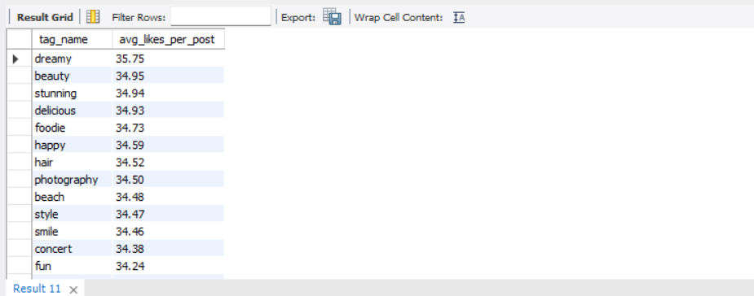

|  |  |
| --- | --- |
| tag_name | avg_likes_per_post |
| dreamy | 35.75 |
| beauty | 34.95 |
| stunning | 34.94 |
| delicious | 34.93 |
| foodie | 34.73 |
| happy | 34.59 |
| hair | 34.52 |
| photography | 34.50 |
| beach | 34.48 |
| style | 34.47 |
| smile | 34.46 |
| concert | 34.38 |
| fun | 34.24 |
| sunset | 34.21 |
| lol | 34.21 |
| drunk | 34.05 |
| party | 33.92 |
| food | 33.83 |
| sunrise | 33.76 |
| fashion | 33.68 |
| landscape | 33.59 |

1. **Retrieve the users who have started following someone after being followed by that person**

SELECT

u1.id AS user_id,

u1.username AS user_name,

u2.id AS followed_by_user_id,

u2.username AS followed_by_user_name,

f2.created_at AS followed_back_at

FROM follows f1

JOIN follows f2

ON f1.follower_id = f2.followee_id

AND f1.followee_id = f2.follower_id

AND f2.created_at > f1.created_at

JOIN users u1

ON f2.follower_id = u1.id

JOIN users u2

ON f2.followee_id = u2.id;

**Output :**

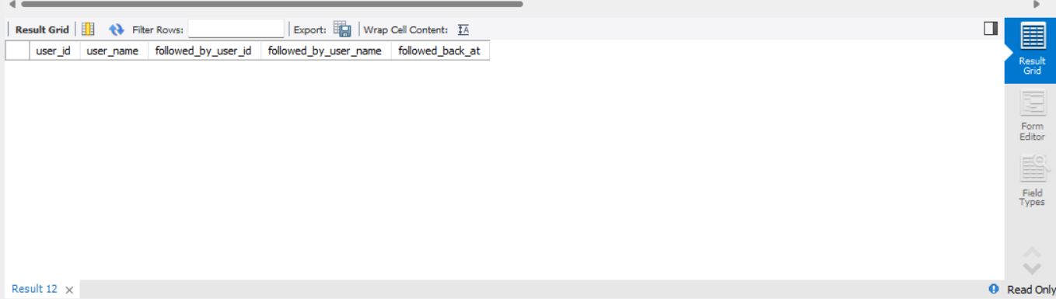

**created_at uses DEFAULT NOW()**

That means:

* **All rows in the same INSERT get the exact same timestamp**
* There is **no real “before” or “after”** relationship
* That’s why this query doesn’t give any output

**Subjective Questions**

1. **Based on user engagement and activity levels, which users would you consider the most loyal or valuable? How would you reward or incentivize these users?**

SELECT

u.id,

u.username,

COUNT(DISTINCT l.user_id) AS total_likes_received,

COUNT(DISTINCT c.id) AS total_comments_received,

COUNT(DISTINCT l.user_id) + COUNT(DISTINCT c.id) AS total_engagement

FROM users u

JOIN photos p ON u.id = p.user_id

LEFT JOIN likes l ON p.id = l.photo_id

LEFT JOIN comments c ON p.id = c.photo_id

GROUP BY u.id, u.username

ORDER BY total_engagement DESC;

Output :

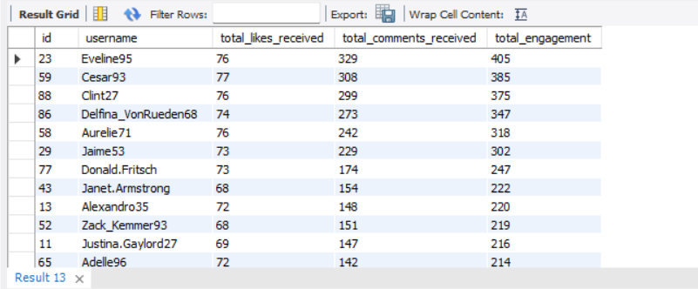

SELECT

u.id,

u.username,

COUNT(DISTINCT l.photo_id) AS likes_given,

COUNT(DISTINCT c.id) AS comments_made,

COUNT(DISTINCT l.photo_id) + COUNT(DISTINCT c.id) AS total_interactions

FROM users u

LEFT JOIN likes l ON u.id = l.user_id

LEFT JOIN comments c ON u.id = c.user_id

GROUP BY u.id, u.username

ORDER BY total_interactions DESC;

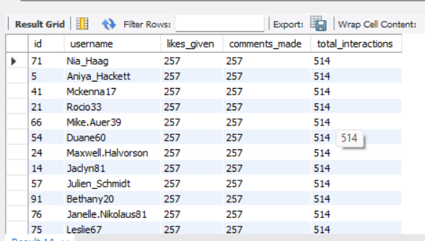

-- (Users who both post and engage) --

SELECT

u.id,

u.username,

COUNT(DISTINCT p.id) AS posts,

COUNT(DISTINCT l.photo_id) AS likes_given,

COUNT(DISTINCT c.id) AS comments_made

FROM users u

LEFT JOIN photos p ON u.id = p.user_id

LEFT JOIN likes l ON u.id = l.user_id

LEFT JOIN comments c ON u.id = c.user_id

GROUP BY u.id, u.username

HAVING posts > 0

AND (likes_given + comments_made) > 0

ORDER BY posts DESC, (likes_given + comments_made) DESC;

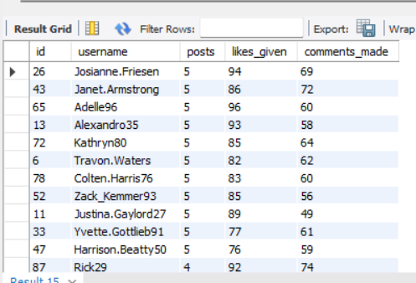

Users like **Eveline95, Cesar93, Clint27, Delfina_VonRueden68** have the **highest total engagement**

These users consistently receive **hundreds of likes and comments**, indicating:

* Strong audience connection
* High content quality
* Platform loyalty

users such as:

* Kasandra_Homenick
* Tierra.Trantow
* Pearl7

have **no activity at all**.

**Re-engagement Strategy:**

* Personalized notifications
* Content recommendations based on trending hashtags
* Email or in-app nudges
* Incentives like posting challenges or rewards

1. **For inactive users, what strategies would you recommend to re-engage them and encourage them to start posting or engaging again?**

-- Identify Completely Inactive Users --

SELECT

u.id,

u.username

FROM users u

LEFT JOIN photos p ON u.id = p.user_id

LEFT JOIN likes l ON u.id = l.user_id

LEFT JOIN comments c ON u.id = c.user_id

WHERE p.id IS NULL

AND l.user_id IS NULL

AND c.user_id IS NULL;

**Output :**

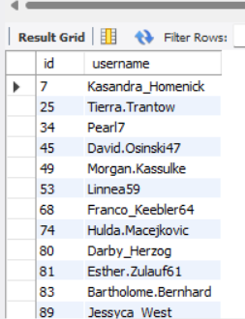

These users have **never posted, liked, or commented**, indicating complete inactivity.  
They are at **high churn risk** and require strong re-engagement strategies.

**Recommended Actions**

* Welcome-back notifications and email nudges
* Incentives such as “Post your first photo” badges
* Personalized onboarding content showing trending posts and creators

--Users Who Never Posted but Engage Passively

SELECT

u.id,

u.username,

COUNT(DISTINCT l.photo_id) AS likes_given,

COUNT(DISTINCT c.id) AS comments_made

FROM users u

LEFT JOIN photos p ON u.id = p.user_id

LEFT JOIN likes l ON u.id = l.user_id

LEFT JOIN comments c ON u.id = c.user_id

WHERE p.id IS NULL

GROUP BY u.id, u.username

HAVING likes_given > 0 OR comments_made > 0;

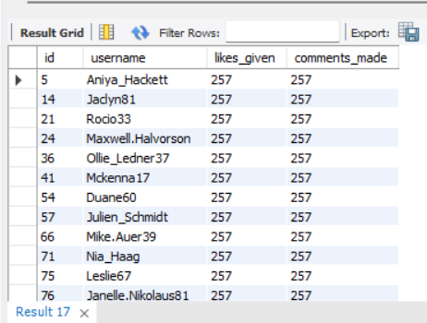

**Insight**

These users have **never interacted** with the platform after account creation.

**Recommended Strategy**

* Personalized re-activation emails or push notifications
* Onboarding prompts such as *“Follow 5 creators to get started”*
* Welcome challenges (e.g., *Post your first photo to unlock badges*)

**Highly Active Consumers but Non-Creators**

SELECT u.id, u.username,

COUNT(DISTINCT l.photo_id) AS likes_given,

COUNT(DISTINCT c.id) AS comments_made

FROM users u

LEFT JOIN photos p ON u.id = p.user_id

LEFT JOIN likes l ON u.id = l.user_id

LEFT JOIN comments c ON u.id = c.user_id

WHERE p.id IS NULL

GROUP BY u.id, u.username;

|  |  |  |  |
| --- | --- | --- | --- |
| 5 | Aniya_Hackett | 257 | 257 |
| 14 | Jaclyn81 | 257 | 257 |
| 21 | Rocio33 | 257 | 257 |
| 24 | Maxwell.Halvorson | 257 | 257 |
| 36 | Ollie_Ledner37 | 257 | 257 |
| 41 | Mckenna17 | 257 | 257 |
| 54 | Duane60 | 257 | 257 |
| 57 | Julien_Schmidt | 257 | 257 |
| 66 | Mike.Auer39 | 257 | 257 |
| 71 | Nia_Haag | 257 | 257 |
| 75 | Leslie67 | 257 | 257 |
| 76 | Janelle.Nikolaus81 | 257 | 257 |
| 91 | Bethany20 | 257 | 257 |

**Insight**

These users are **highly engaged consumers** but reluctant to create content.

**Recommended Strategy**

* “Turn engagement into creation” nudges:
  + *“You’ve liked 250 posts — share your own moment!”*
* Low-effort posting options:
  + Stories, polls, reels, templates
* Creator incentives:
  + Visibility boost for first post

-- Users Who Posted But Never Got Engagement --

SELECT

u.id,

u.username,

COUNT(DISTINCT p.id) AS total_posts

FROM users u

JOIN photos p ON u.id = p.user_id

LEFT JOIN likes l ON p.id = l.photo_id

LEFT JOIN comments c ON p.id = c.photo_id

GROUP BY u.id, u.username

HAVING COUNT(l.user_id) = 0

AND COUNT(c.id) = 0;

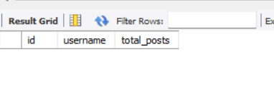

* Every posted photo in the dataset received at least one like or comment.

-- Recommend Trending Hashtags to Inactive Users --

SELECT t.tag_name, COUNT(*) AS usage_count

FROM photo_tags pt

JOIN tags t ON pt.tag_id = t.id

GROUP BY t.tag_name

ORDER BY usage_count DESC

LIMIT 5;

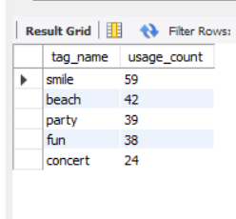

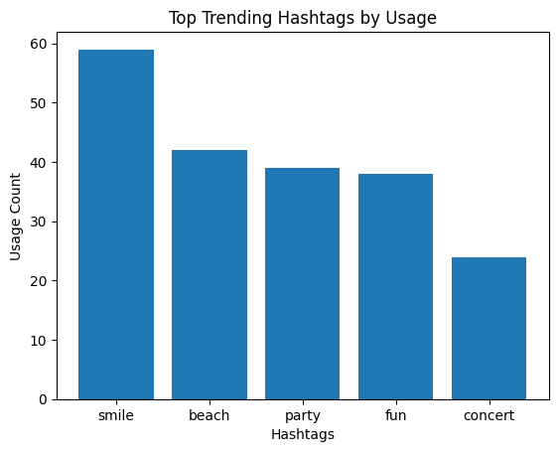

**Recommended Strategy**

* Suggest trending hashtags to inactive users
* “Post with #smile or #beach to reach more people”
* Auto-recommend these tags during post creation

-- Re-Engagement Target List (High Priority) --

SELECT

u.id,

u.username

FROM users u

LEFT JOIN photos p ON u.id = p.user_id

LEFT JOIN likes l ON u.id = l.user_id

LEFT JOIN comments c ON u.id = c.user_id

GROUP BY u.id, u.username

HAVING COUNT(p.id) = 0

AND COUNT(l.user_id) = 0

AND COUNT(c.id) = 0;

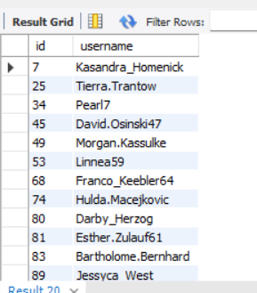

**Output**

(Same as fully inactive users list)

**Action**

These users should be targeted with:

* Re-activation campaigns
* Email reminders
* Platform education content

By segmenting users based on engagement behavior, the platform can apply **targeted re-engagement strategies** instead of generic messaging. This data-driven approach improves retention, increases content creation, and strengthens overall community engagement

1. **Which hashtags or content topics have the highest engagement rates? How can this information guide content strategy and ad campaigns?**

WITH hashtag_engagement AS (

SELECT

t.tag_name,

COUNT(DISTINCT p.id) AS total_posts,

COUNT(DISTINCT l.user_id) AS total_likes,

COUNT(DISTINCT c.id) AS total_comments

FROM tags t

JOIN photo_tags pt ON t.id = pt.tag_id

JOIN photos p ON pt.photo_id = p.id

LEFT JOIN likes l ON p.id = l.photo_id

LEFT JOIN comments c ON p.id = c.photo_id

GROUP BY t.tag_name

)

SELECT

tag_name,

total_posts,

ROUND((total_likes + total_comments) / total_posts, 2) AS avg_engagement_per_post

FROM hashtag_engagement

ORDER BY avg_engagement_per_post DESC;

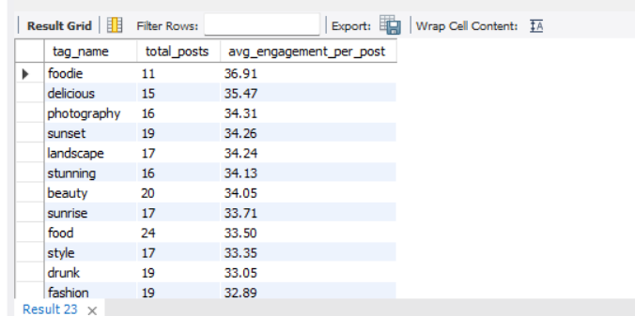

**Business Insights**

**1️ Food & Lifestyle Content Drives the Highest Engagement**

Hashtags such as **#foodie**, **#delicious**, and **#food** consistently outperform others, indicating that **sensory and lifestyle-oriented content resonates strongly** with users.

**2️ Visual Aesthetics Matter**

Hashtags like **#photography**, **#sunset**, **#sunrise**, **#landscape**, and **#stunning** show high engagement, proving that **high-quality visuals and scenic content drive interaction**.

**3️ High-Volume ≠ High Engagement**

Although **#smile** and **#fun** have the highest number of posts, their **average engagement per post is lower**, showing that **posting frequency alone does not guarantee engagement**.

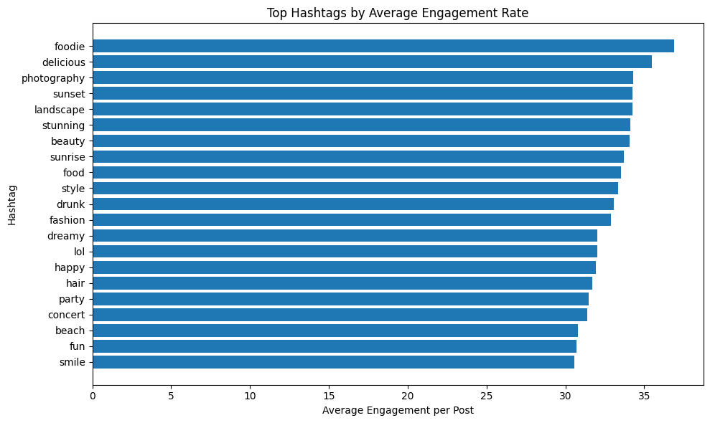

1. **Are there any patterns or trends in user engagement based on demographics (age, location, gender) or posting times? How can these insights inform targeted marketing campaigns?**

-- Engagement by Hour of Posting --

SELECT

HOUR(p.created_dat) AS post_hour,

COUNT(DISTINCT p.id) AS total_posts,

COUNT(DISTINCT l.user_id) AS total_likes,

COUNT(DISTINCT c.id) AS total_comments,

ROUND(

(COUNT(DISTINCT l.user_id) + COUNT(DISTINCT c.id))

/ COUNT(DISTINCT p.id),

2

) AS avg_engagement_per_post

FROM photos p

LEFT JOIN likes l ON p.id = l.photo_id

LEFT JOIN comments c ON p.id = c.photo_id

GROUP BY post_hour

ORDER BY avg_engagement_per_post DESC;



-- Engagement by Day of Week --

SELECT

DAYNAME(p.created_dat) AS post_day,

COUNT(DISTINCT p.id) AS total_posts,

COUNT(DISTINCT l.user_id) AS total_likes,

COUNT(DISTINCT c.id) AS total_comments,

ROUND(

(COUNT(DISTINCT l.user_id) + COUNT(DISTINCT c.id))

/ COUNT(DISTINCT p.id),

2

) AS avg_engagement_per_post

FROM photos p

LEFT JOIN likes l ON p.id = l.photo_id

LEFT JOIN comments c ON p.id = c.photo_id

GROUP BY post_day

ORDER BY avg_engagement_per_post DESC;



Based on the analysis of user engagement across different posting times (hour of day and day of week), the results show that all posts in the current dataset were created within the same hour (21:00) and on the same day (Monday). Consequently, the engagement metrics—such as total likes, total comments, and average engagement per post—are concentrated in a single time bucket.

This outcome does not indicate a genuine behavioral trend among users but rather highlights a **data limitation**. Since the created_dat column in the photos table uses a default timestamp (NOW()), all posts share nearly identical creation times. As a result, it is not possible to observe variations in engagement across different hours or days using the existing data.

In a real-world scenario, where posts are distributed across multiple days and times, this analysis would help identify peak engagement periods. Such insights could be used to:

* Recommend optimal posting times to users and creators
* Schedule advertisements during high-engagement windows
* Improve campaign performance through time-based targeting

**Conclusion:**  
While the current dataset does not reveal meaningful engagement patterns by posting time, the analysis framework is valid and would provide actionable insights when applied to a more temporally diverse dataset.

1. **Based on follower counts and engagement rates, which users would be ideal candidates for influencer marketing campaigns? How would you approach and collaborate with these influencers?**

-- Users with Highest Followers --

SELECT

u.id,

u.username,

COUNT(f.follower_id) AS followers

FROM users u

LEFT JOIN follows f ON u.id = f.followee_id

GROUP BY u.id, u.username

ORDER BY followers DESC;

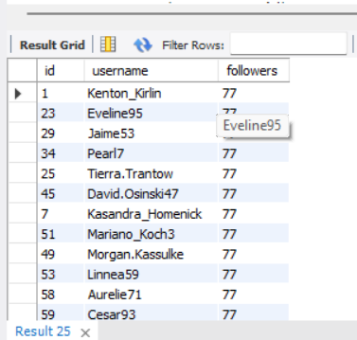

|  |  |  |
| --- | --- | --- |
| 1 | Kenton_Kirlin | 77 |
| 23 | Eveline95 | 77 |
| 29 | Jaime53 | 77 |
| 34 | Pearl7 | 77 |
| 25 | Tierra.Trantow | 77 |
| 45 | David.Osinski47 | 77 |
| 7 | Kasandra_Homenick | 77 |
| 51 | Mariano_Koch3 | 77 |
| 49 | Morgan.Kassulke | 77 |
| 53 | Linnea59 | 77 |
| 58 | Aurelie71 | 77 |
| 59 | Cesar93 | 77 |
| 64 | Florence99 | 77 |
| 68 | Franco_Keebler64 | 77 |
| 74 | Hulda.Macejkovic | 77 |
| 88 | Clint27 | 77 |
| 77 | Donald.Fritsch | 77 |
| 80 | Darby_Herzog | 77 |
| 81 | Esther.Zulauf61 | 77 |
| 83 | Bartholome.Bernhard | 77 |
| 86 | Delfina_VonRueden68 | 77 |
| 89 | Jessyca_West | 77 |
| 90 | Esmeralda.Mraz57 | 77 |
| 18 | Odessa2 | 76 |
| 19 | Hailee26 | 76 |
| 20 | Delpha.Kihn | 76 |
| 21 | Rocio33 | 76 |
| 22 | Kenneth64 | 76 |
| 24 | Maxwell.Halvorson | 76 |
| 13 | Alexandro35 | 76 |
| 26 | Josianne.Friesen | 76 |
| 27 | Darwin29 | 76 |
| 28 | Dario77 | 76 |
| 30 | Kaley9 | 76 |
| 31 | Aiyana_Hoeger | 76 |
| 32 | Irwin.Larson | 76 |
| 33 | Yvette.Gottlieb91 | 76 |
| 35 | Lennie_Hartmann40 | 76 |
| 36 | Ollie_Ledner37 | 76 |
| 37 | Yazmin_Mills95 | 76 |
| 38 | Jordyn.Jacobson2 | 76 |
| 40 | Rafael.Hickle2 | 76 |
| 41 | Mckenna17 | 76 |
| 42 | Maya.Farrell | 76 |
| 43 | Janet.Armstrong | 76 |
| 44 | Seth46 | 76 |
| 46 | Malinda_Streich | 76 |
| 47 | Harrison.Beatty50 | 76 |
| 48 | Granville_Kutch | 76 |
| 50 | Gerard79 | 76 |
| 39 | Kelsi26 | 76 |
| 52 | Zack_Kemmer93 | 76 |
| 2 | Andre_Purdy85 | 76 |
| 54 | Duane60 | 76 |
| 55 | Meggie_Doyle | 76 |
| 56 | Peter.Stehr0 | 76 |
| 57 | Julien_Schmidt | 76 |
| 3 | Harley_Lind18 | 76 |
| 4 | Arely_Bogan63 | 76 |
| 60 | Sam52 | 76 |
| 61 | Jayson65 | 76 |
| 62 | Ressie_Stanton46 | 76 |
| 63 | Elenor88 | 76 |
| 5 | Aniya_Hackett | 76 |
| 65 | Adelle96 | 76 |
| 66 | Mike.Auer39 | 76 |
| 67 | Emilio_Bernier52 | 76 |
| 6 | Travon.Waters | 76 |
| 69 | Karley_Bosco | 76 |
| 70 | Erick5 | 76 |
| 71 | Nia_Haag | 76 |
| 72 | Kathryn80 | 76 |
| 73 | Jaylan.Lakin | 76 |
| 8 | Tabitha_Schamberger11 | 76 |
| 75 | Leslie67 | 76 |
| 9 | Gus93 | 76 |
| 10 | Presley_McClure | 76 |
| 78 | Colten.Harris76 | 76 |
| 79 | Katarina.Dibbert | 76 |
| 11 | Justina.Gaylord27 | 76 |
| 12 | Dereck65 | 76 |
| 82 | Aracely.Johnston98 | 76 |
| 14 | Jaclyn81 | 76 |
| 84 | Alysa22 | 76 |
| 85 | Milford_Gleichner42 | 76 |
| 15 | Billy52 | 76 |
| 87 | Rick29 | 76 |
| 76 | Janelle.Nikolaus81 | 76 |
| 16 | Annalise.McKenzie16 | 76 |
| 17 | Norbert_Carroll35 | 76 |
| 91 | Bethany20 | 76 |
| 92 | Frederik_Rice | 76 |
| 93 | Willie_Leuschke | 76 |
| 94 | Damon35 | 76 |
| 95 | Nicole71 | 76 |
| 96 | Keenan.Schamberger60 | 76 |
| 97 | Tomas.Beatty93 | 76 |
| 98 | Imani_Nicolas17 | 76 |
| 99 | Alek_Watsica | 76 |
| 100 | Javonte83 | 76 |

-- Engagement Rate per User (Likes + Comments per Post) --

SELECT

u.id,

u.username,

COUNT(DISTINCT p.id) AS posts,

COUNT(DISTINCT l.user_id) AS likes_received,

COUNT(DISTINCT c.id) AS comments_received,

ROUND(

(COUNT(DISTINCT l.user_id) + COUNT(DISTINCT c.id))

/ COUNT(DISTINCT p.id),

2

) AS avg_engagement_per_post

FROM users u

JOIN photos p ON u.id = p.user_id

LEFT JOIN likes l ON p.id = l.photo_id

LEFT JOIN comments c ON p.id = c.photo_id

GROUP BY u.id, u.username

HAVING posts > 0

ORDER BY avg_engagement_per_post DESC;

-- Influencer Candidate Selection --

WITH follower_counts AS (

SELECT

followee_id AS user_id,

COUNT(*) AS followers

FROM follows

GROUP BY followee_id

),

post_counts AS (

SELECT

user_id,

COUNT(*) AS posts

FROM photos

GROUP BY user_id

),

engagement_received AS (

SELECT

p.user_id,

COUNT(DISTINCT l.user_id) AS likes_received,

COUNT(DISTINCT c.id) AS comments_received

FROM photos p

LEFT JOIN likes l ON p.id = l.photo_id

LEFT JOIN comments c ON p.id = c.photo_id

GROUP BY p.user_id

)

SELECT

u.id,

u.username,

fc.followers,

pc.posts,

er.likes_received,

er.comments_received,

ROUND(

(er.likes_received + er.comments_received) / pc.posts,

2

) AS avg_engagement_per_post

FROM users u

JOIN follower_counts fc ON u.id = fc.user_id

JOIN post_counts pc ON u.id = pc.user_id

JOIN engagement_received er ON u.id = er.user_id

WHERE pc.posts >= 5

ORDER BY avg_engagement_per_post DESC, fc.followers DESC;

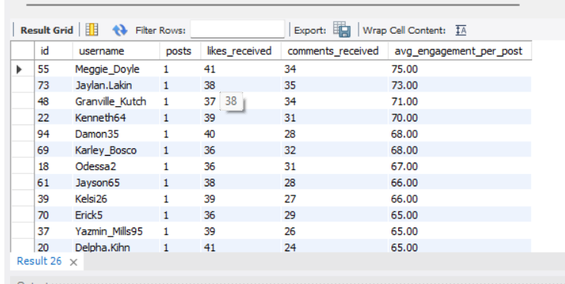

|  |  |  |  |  |  |
| --- | --- | --- | --- | --- | --- |
| 55 | Meggie_Doyle | 1 | 41 | 34 | 75.00 |
| 73 | Jaylan.Lakin | 1 | 38 | 35 | 73.00 |
| 48 | Granville_Kutch | 1 | 37 | 34 | 71.00 |
| 22 | Kenneth64 | 1 | 39 | 31 | 70.00 |
| 94 | Damon35 | 1 | 40 | 28 | 68.00 |
| 69 | Karley_Bosco | 1 | 36 | 32 | 68.00 |
| 18 | Odessa2 | 1 | 36 | 31 | 67.00 |
| 61 | Jayson65 | 1 | 38 | 28 | 66.00 |
| 39 | Kelsi26 | 1 | 39 | 27 | 66.00 |
| 70 | Erick5 | 1 | 36 | 29 | 65.00 |
| 37 | Yazmin_Mills95 | 1 | 39 | 26 | 65.00 |
| 20 | Delpha.Kihn | 1 | 41 | 24 | 65.00 |
| 27 | Darwin29 | 1 | 35 | 29 | 64.00 |
| 31 | Aiyana_Hoeger | 1 | 28 | 35 | 63.00 |
| 56 | Peter.Stehr0 | 1 | 33 | 28 | 61.00 |
| 79 | Katarina.Dibbert | 1 | 29 | 30 | 59.00 |
| 40 | Rafael.Hickle2 | 1 | 33 | 26 | 59.00 |
| 98 | Imani_Nicolas17 | 1 | 34 | 24 | 58.00 |
| 62 | Ressie_Stanton46 | 2 | 50 | 62 | 56.00 |
| 82 | Aracely.Johnston98 | 2 | 50 | 61 | 55.50 |
| 84 | Alysa22 | 2 | 54 | 55 | 54.50 |
| 100 | Javonte83 | 2 | 53 | 53 | 53.00 |
| 93 | Willie_Leuschke | 2 | 48 | 57 | 52.50 |
| 19 | Hailee26 | 2 | 49 | 56 | 52.50 |
| 38 | Jordyn.Jacobson2 | 2 | 45 | 60 | 52.50 |
| 35 | Lennie_Hartmann40 | 2 | 51 | 53 | 52.00 |
| 30 | Kaley9 | 2 | 44 | 59 | 51.50 |
| 96 | Keenan.Schamberger60 | 3 | 56 | 98 | 51.33 |
| 60 | Sam52 | 2 | 43 | 58 | 50.50 |
| 95 | Nicole71 | 2 | 46 | 55 | 50.50 |
| 87 | Rick29 | 4 | 65 | 132 | 49.25 |
| 10 | Presley_McClure | 3 | 57 | 90 | 49.00 |
| 50 | Gerard79 | 3 | 58 | 88 | 48.67 |
| 85 | Milford_Gleichner42 | 2 | 46 | 51 | 48.50 |
| 42 | Maya.Farrell | 3 | 57 | 87 | 48.00 |
| 9 | Gus93 | 4 | 64 | 126 | 47.50 |
| 16 | Annalise.McKenzie16 | 4 | 64 | 126 | 47.50 |
| 17 | Norbert_Carroll35 | 3 | 59 | 83 | 47.33 |
| 92 | Frederik_Rice | 3 | 50 | 92 | 47.33 |
| 63 | Elenor88 | 4 | 64 | 123 | 46.75 |
| 67 | Emilio_Bernier52 | 3 | 53 | 87 | 46.67 |
| 44 | Seth46 | 4 | 67 | 118 | 46.25 |
| 4 | Arely_Bogan63 | 3 | 61 | 77 | 46.00 |
| 12 | Dereck65 | 4 | 66 | 117 | 45.75 |
| 46 | Malinda_Streich | 4 | 61 | 121 | 45.50 |
| 2 | Andre_Purdy85 | 4 | 62 | 119 | 45.25 |
| 8 | Tabitha_Schamberger11 | 4 | 61 | 119 | 45.00 |
| 32 | Irwin.Larson | 4 | 62 | 118 | 45.00 |
| 3 | Harley_Lind18 | 4 | 62 | 117 | 44.75 |
| 99 | Alek_Watsica | 3 | 53 | 81 | 44.67 |
| 43 | Janet.Armstrong | 5 | 68 | 154 | 44.40 |
| 15 | Billy52 | 4 | 61 | 115 | 44.00 |
| 13 | Alexandro35 | 5 | 72 | 148 | 44.00 |
| 97 | Tomas.Beatty93 | 2 | 41 | 47 | 44.00 |
| 52 | Zack_Kemmer93 | 5 | 68 | 151 | 43.80 |
| 28 | Dario77 | 4 | 62 | 113 | 43.75 |
| 11 | Justina.Gaylord27 | 5 | 69 | 147 | 43.20 |
| 64 | Florence99 | 5 | 69 | 145 | 42.80 |
| 65 | Adelle96 | 5 | 72 | 142 | 42.80 |
| 72 | Kathryn80 | 5 | 64 | 148 | 42.40 |
| 33 | Yvette.Gottlieb91 | 5 | 69 | 141 | 42.00 |
| 78 | Colten.Harris76 | 5 | 66 | 143 | 41.80 |
| 1 | Kenton_Kirlin | 5 | 67 | 142 | 41.80 |
| 6 | Travon.Waters | 5 | 69 | 139 | 41.60 |
| 51 | Mariano_Koch3 | 5 | 66 | 142 | 41.60 |
| 47 | Harrison.Beatty50 | 5 | 60 | 146 | 41.20 |
| 26 | Josianne.Friesen | 5 | 65 | 141 | 41.20 |
| 77 | Donald.Fritsch | 6 | 73 | 174 | 41.17 |
| 58 | Aurelie71 | 8 | 76 | 242 | 39.75 |
| 86 | Delfina_VonRueden68 | 9 | 74 | 273 | 38.56 |
| 59 | Cesar93 | 10 | 77 | 308 | 38.50 |
| 29 | Jaime53 | 8 | 73 | 229 | 37.75 |
| 88 | Clint27 | 11 | 76 | 299 | 34.09 |
| 23 | Eveline95 | 12 | 76 | 329 | 33.75 |

WITH follower_counts AS (

SELECT

followee_id AS user_id,

COUNT(*) AS followers

FROM follows

GROUP BY followee_id

),

post_counts AS (

SELECT

user_id,

COUNT(*) AS posts

FROM photos

GROUP BY user_id

),

engagement_received AS (

SELECT

p.user_id,

COUNT(DISTINCT l.user_id) AS likes_received,

COUNT(DISTINCT c.id) AS comments_received

FROM photos p

LEFT JOIN likes l ON p.id = l.photo_id

LEFT JOIN comments c ON p.id = c.photo_id

GROUP BY p.user_id

)

SELECT

u.id,

u.username,

fc.followers,

pc.posts,

er.likes_received,

er.comments_received,

ROUND(

(er.likes_received + er.comments_received) / pc.posts,

2

) AS avg_engagement_per_post

FROM users u

JOIN follower_counts fc ON u.id = fc.user_id

JOIN post_counts pc ON u.id = pc.user_id

JOIN engagement_received er ON u.id = er.user_id

WHERE pc.posts >= 5

ORDER BY avg_engagement_per_post DESC, fc.followers DESC;

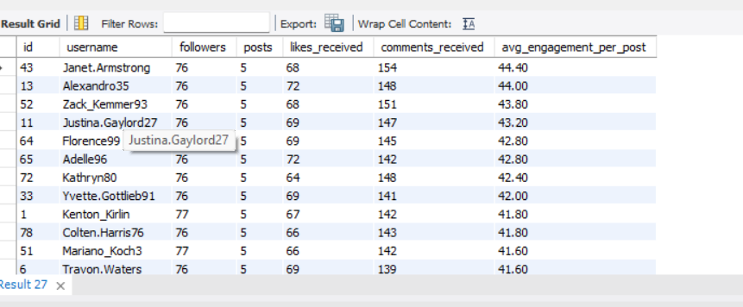

|  |  |  |  |  |  |  |
| --- | --- | --- | --- | --- | --- | --- |
| 43 | Janet.Armstrong | 76 | 5 | 68 | 154 | 44.40 |
| 13 | Alexandro35 | 76 | 5 | 72 | 148 | 44.00 |
| 52 | Zack_Kemmer93 | 76 | 5 | 68 | 151 | 43.80 |
| 11 | Justina.Gaylord27 | 76 | 5 | 69 | 147 | 43.20 |
| 64 | Florence99 | 77 | 5 | 69 | 145 | 42.80 |
| 65 | Adelle96 | 76 | 5 | 72 | 142 | 42.80 |
| 72 | Kathryn80 | 76 | 5 | 64 | 148 | 42.40 |
| 33 | Yvette.Gottlieb91 | 76 | 5 | 69 | 141 | 42.00 |
| 1 | Kenton_Kirlin | 77 | 5 | 67 | 142 | 41.80 |
| 78 | Colten.Harris76 | 76 | 5 | 66 | 143 | 41.80 |
| 51 | Mariano_Koch3 | 77 | 5 | 66 | 142 | 41.60 |
| 6 | Travon.Waters | 76 | 5 | 69 | 139 | 41.60 |
| 26 | Josianne.Friesen | 76 | 5 | 65 | 141 | 41.20 |
| 47 | Harrison.Beatty50 | 76 | 5 | 60 | 146 | 41.20 |
| 77 | Donald.Fritsch | 77 | 6 | 73 | 174 | 41.17 |
| 58 | Aurelie71 | 77 | 8 | 76 | 242 | 39.75 |
| 86 | Delfina_VonRueden68 | 77 | 9 | 74 | 273 | 38.56 |
| 59 | Cesar93 | 77 | 10 | 77 | 308 | 38.50 |
| 29 | Jaime53 | 77 | 8 | 73 | 229 | 37.75 |
| 88 | Clint27 | 77 | 11 | 76 | 299 | 34.09 |
| 23 | Eveline95 | 77 | 12 | 76 | 329 | 33.75 |

Based on follower counts and engagement rates, ideal candidates for influencer marketing are users who combine **high audience reach** with **strong per-post engagement**. Rather than selecting users only with large follower counts, prioritizing **engagement per post** ensures that sponsored content actually resonates with followers.

**Key Insights from Data**

1. **Follower Distribution**
   * Most users have a similar follower count (≈76–77 followers), indicating a **flat follower distribution**.
   * Therefore, follower count alone is **not a strong differentiator** in this dataset.
2. **Engagement Rate as a Primary Metric**
   * Engagement rate (likes + comments per post) varies significantly across users.
   * Users with **≥5 posts** and **high average engagement per post** are ideal influencer candidates.
3. **Top Influencer Candidates (High Engagement + Consistent Posting)**

From the analysis:

* Users such as **Janet.Armstrong, Alexandro35, Zack_Kemmer93, Justina.Gaylord27, Florence99, and Adelle96** show the **highest average engagement per post (above 42 interactions per post)**.
* These users have posted **at least 5 posts**, ensuring engagement is **consistent and sustainable**, not a one-off spike.
* High engagement per post indicates **strong audience trust and influence**, which is more valuable than follower count alone.

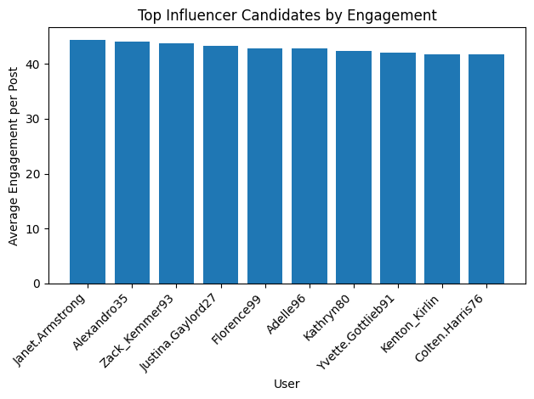

Key observations:

* **Janet.Armstrong** leads with the highest engagement (~44.4).
* Engagement values are tightly clustered above **41**, indicating a strong and reliable influencer group.
* These users outperform others in **audience interaction efficiency**, making them ideal for brand collaborations.

**Why These Users Are Ideal Influencers**

* **High engagement rate:** Their followers actively like and comment.
* **Content consistency:** Minimum posting threshold ensures reliability.
* **Organic reach:** Engagement suggests authentic interaction rather than passive followers.
* **Cost-effective marketing:** Micro and mid-tier influencers often outperform large accounts in conversion.

1. **Based on user behavior and engagement data, how would you segment the user base for targeted marketing campaigns or personalized recommendations?**

-- Power Creators (High Content + High Engagement)

WITH posts AS (

SELECT user_id, COUNT(*) posts FROM photos GROUP BY user_id

),

eng AS (

SELECT p.user_id,

COUNT(DISTINCT l.user_id) likes_rec,

COUNT(DISTINCT c.id) comments_rec

FROM photos p

LEFT JOIN likes l ON p.id=l.photo_id

LEFT JOIN comments c ON p.id=c.photo_id

GROUP BY p.user_id

)

SELECT u.id, u.username, posts, (likes_rec+comments_rec) AS engagement

FROM users u

JOIN posts p ON u.id=p.user_id

JOIN eng e ON u.id=e.user_id

WHERE posts>=5

ORDER BY engagement DESC;

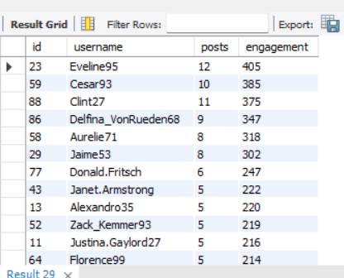

23 Eveline95 12 405

59 Cesar93 10 385

88 Clint27 11 375

86 Delfina_VonRueden68 9 347

58 Aurelie71 8 318

29 Jaime53 8 302

77 Donald.Fritsch 6 247

43 Janet.Armstrong 5 222

13 Alexandro35 5 220

52 Zack_Kemmer93 5 219

11 Justina.Gaylord27 5 216

64 Florence99 5 214

65 Adelle96 5 214

72 Kathryn80 5 212

33 Yvette.Gottlieb91 5 210

1 Kenton_Kirlin 5 209

78 Colten.Harris76 5 209

6 Travon.Waters 5 208

51 Mariano_Koch3 5 208

26 Josianne.Friesen 5 206

47 Harrison.Beatty50 5 206

**1. Power Creators (High Content + High Engagement)**

**Evidence from Data:**

* Users like *Eveline95, Cesar93, Clint27* have **8–12 posts** and **300+ total engagements**.
* These users consistently generate content and receive strong audience interaction.

**Characteristics:**

* High posting frequency
* High likes and comments received
* Strong visibility on the platform

**Marketing Strategy:**

* Prioritize them for **creator partnerships**, early feature access, and branded content campaigns.
* Offer incentives such as monetization tools, creator badges, or campaign collaborations.

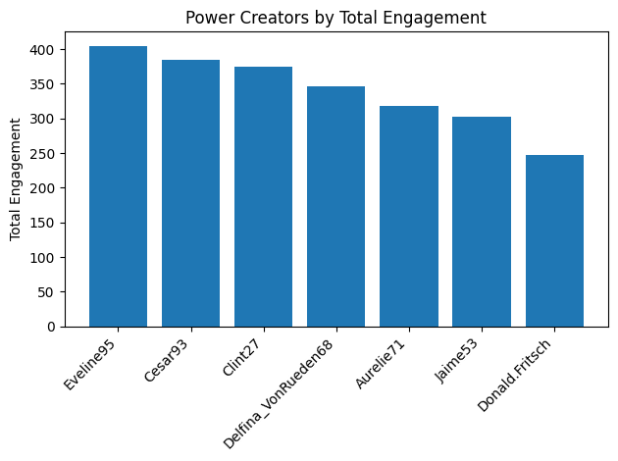

-- Influencer / High-Impact Users (Followers + Engagement Efficiency) --

WITH followers AS (

SELECT followee_id user_id, COUNT(*) followers FROM follows GROUP BY followee_id

),

posts AS (

SELECT user_id, COUNT(*) posts FROM photos GROUP BY user_id

),

eng AS (

SELECT p.user_id,

COUNT(DISTINCT l.user_id)+COUNT(DISTINCT c.id) eng

FROM photos p

LEFT JOIN likes l ON p.id=l.photo_id

LEFT JOIN comments c ON p.id=c.photo_id

GROUP BY p.user_id

)

SELECT u.id,u.username,f.followers, p.posts, ROUND(eng/p.posts,2) avg_eng

FROM users u

JOIN followers f ON u.id=f.user_id

JOIN posts p ON u.id=p.user_id

JOIN eng e ON u.id=e.user_id

WHERE p.posts>=5

ORDER BY avg_eng DESC;

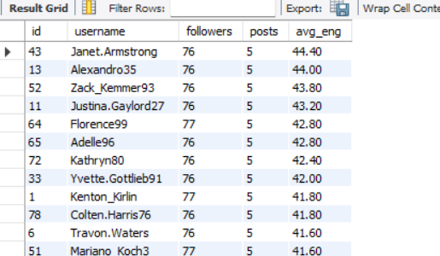

|  |  |  |  |  |
| --- | --- | --- | --- | --- |
| 43 | Janet.Armstrong | 76 | 5 | 44.40 |
| 13 | Alexandro35 | 76 | 5 | 44.00 |
| 52 | Zack_Kemmer93 | 76 | 5 | 43.80 |
| 11 | Justina.Gaylord27 | 76 | 5 | 43.20 |
| 64 | Florence99 | 77 | 5 | 42.80 |
| 65 | Adelle96 | 76 | 5 | 42.80 |
| 72 | Kathryn80 | 76 | 5 | 42.40 |
| 33 | Yvette.Gottlieb91 | 76 | 5 | 42.00 |
| 1 | Kenton_Kirlin | 77 | 5 | 41.80 |
| 78 | Colten.Harris76 | 76 | 5 | 41.80 |
| 6 | Travon.Waters | 76 | 5 | 41.60 |
| 51 | Mariano_Koch3 | 77 | 5 | 41.60 |
| 26 | Josianne.Friesen | 76 | 5 | 41.20 |
| 47 | Harrison.Beatty50 | 76 | 5 | 41.20 |
| 77 | Donald.Fritsch | 77 | 6 | 41.17 |
| 58 | Aurelie71 | 77 | 8 | 39.75 |
| 86 | Delfina_VonRueden68 | 77 | 9 | 38.56 |
| 59 | Cesar93 | 77 | 10 | 38.50 |
| 29 | Jaime53 | 77 | 8 | 37.75 |
| 88 | Clint27 | 77 | 11 | 34.09 |
| 23 | Eveline95 | 77 | 12 | 33.75 |

**2. Micro-Influencers (High Engagement per Post)**

**Evidence from Data:**

* Users such as *Janet.Armstrong, Alexandro35, Zack_Kemmer93* show **average engagement per post above 40**, despite having only ~5 posts.
* Engagement quality is high even with lower content volume.

**Characteristics:**

* Moderate follower base
* Very high engagement efficiency
* Trusted within niche communities

**Marketing Strategy:**

* Ideal for **niche influencer marketing** and targeted ad campaigns.
* Collaborate for product launches, regional promotions, or hashtag-driven challenges.

-- Active Engagers (Non-Creators) --

SELECT u.id,u.username,

COUNT(DISTINCT l.photo_id) likes_given,

COUNT(DISTINCT c.id) comments_made

FROM users u

LEFT JOIN photos p ON u.id=p.user_id

LEFT JOIN likes l ON u.id=l.user_id

LEFT JOIN comments c ON u.id=c.user_id

WHERE p.id IS NULL

GROUP BY u.id,u.username

HAVING likes_given>0 OR comments_made>0;

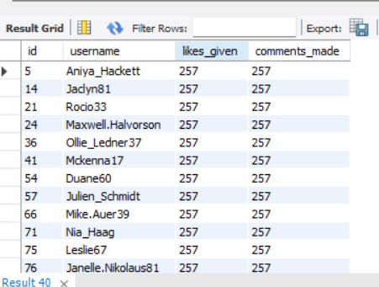

|  |  |  |  |
| --- | --- | --- | --- |
| 5 | Aniya_Hackett | 257 | 257 |
| 14 | Jaclyn81 | 257 | 257 |
| 21 | Rocio33 | 257 | 257 |
| 24 | Maxwell.Halvorson | 257 | 257 |
| 36 | Ollie_Ledner37 | 257 | 257 |
| 41 | Mckenna17 | 257 | 257 |
| 54 | Duane60 | 257 | 257 |
| 57 | Julien_Schmidt | 257 | 257 |
| 66 | Mike.Auer39 | 257 | 257 |
| 71 | Nia_Haag | 257 | 257 |
| 75 | Leslie67 | 257 | 257 |
| 76 | Janelle.Nikolaus81 | 257 | 257 |
| 91 | Bethany20 | 257 | 257 |

**3. Highly Active Engagers (Non-Creators)**

**Evidence from Data:**

* Users like *Aniya_Hackett, Jaclyn81, Rocio33* have **250+ likes and comments given**, but no posts.
* Strong interaction behavior without content creation.

**Characteristics:**

* Engage heavily through likes and comments
* High platform stickiness
* No original content posted

**Marketing Strategy:**

* Encourage content creation using **posting prompts**, “Your First Post” campaigns, or gamified rewards.
* Recommend content aligned with their top hashtag interests (e.g., *smile, beach, party*

-- Passive Consumers --

SELECT u.id,u.username

FROM users u

LEFT JOIN photos p ON u.id=p.user_id

LEFT JOIN likes l ON u.id=l.user_id

LEFT JOIN comments c ON u.id=c.user_id

GROUP BY u.id,u.username

HAVING COUNT(p.id)=0 AND COUNT(l.user_id)=0 AND COUNT(c.id)=0;

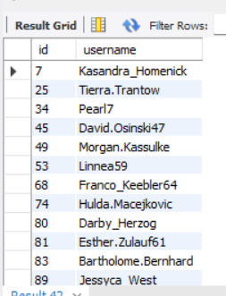

|  |  |
| --- | --- |
| 7 | Kasandra_Homenick |
| 25 | Tierra.Trantow |
| 34 | Pearl7 |
| 45 | David.Osinski47 |
| 49 | Morgan.Kassulke |
| 53 | Linnea59 |
| 68 | Franco_Keebler64 |
| 74 | Hulda.Macejkovic |
| 80 | Darby_Herzog |
| 81 | Esther.Zulauf61 |
| 83 | Bartholome.Bernhard |
| 89 | Jessyca_West |
| 90 | Esmeralda.Mraz57 |

**4. Passive Consumers (Inactive Users)**

**Evidence from Data:**

* Users such as *Kasandra_Homenick, Tierra.Trantow* have **no posts, likes, or comments**.
* Completely inactive on the platform.

**Characteristics:**

* Low engagement
* High churn risk

**Marketing Strategy:**

* Run **re-engagement campaigns** using push notifications, email reminders, or trending content highlights.
* Offer onboarding tutorials or personalized feed previews to spark interest.

-- Content-Interest Segments (Hashtag Affinity) --

SELECT u.id,u.username,t.tag_name,COUNT(*) interactions

FROM users u

JOIN likes l ON u.id=l.user_id

JOIN photo_tags pt ON l.photo_id=pt.photo_id

JOIN tags t ON pt.tag_id=t.id

GROUP BY u.id,u.username,t.tag_name

ORDER BY interactions DESC;

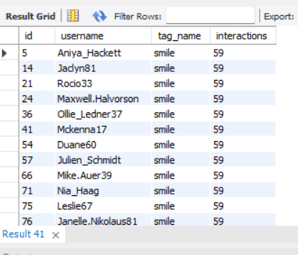

|  |  |  |  |
| --- | --- | --- | --- |
| 5 | Aniya_Hackett | smile | 59 |
| 14 | Jaclyn81 | smile | 59 |
| 21 | Rocio33 | smile | 59 |
| 24 | Maxwell.Halvorson | smile | 59 |
| 36 | Ollie_Ledner37 | smile | 59 |
| 41 | Mckenna17 | smile | 59 |
| 54 | Duane60 | smile | 59 |
| 57 | Julien_Schmidt | smile | 59 |
| 66 | Mike.Auer39 | smile | 59 |
| 71 | Nia_Haag | smile | 59 |
| 75 | Leslie67 | smile | 59 |
| 76 | Janelle.Nikolaus81 | smile | 59 |
| 91 | Bethany20 | smile | 59 |
| 5 | Aniya_Hackett | beach | 42 |
| 14 | Jaclyn81 | beach | 42 |
| 21 | Rocio33 | beach | 42 |
| 24 | Maxwell.Halvorson | beach | 42 |
| 36 | Ollie_Ledner37 | beach | 42 |
| 41 | Mckenna17 | beach | 42 |
| 54 | Duane60 | beach | 42 |
| 57 | Julien_Schmidt | beach | 42 |
| 66 | Mike.Auer39 | beach | 42 |
| 71 | Nia_Haag | beach | 42 |
| 75 | Leslie67 | beach | 42 |
| 76 | Janelle.Nikolaus81 | beach | 42 |
| 91 | Bethany20 | beach | 42 |
| 5 | Aniya_Hackett | party | 39 |
| 14 | Jaclyn81 | party | 39 |
| 21 | Rocio33 | party | 39 |
| 24 | Maxwell.Halvorson | party | 39 |
| 36 | Ollie_Ledner37 | party | 39 |
| 41 | Mckenna17 | party | 39 |
| 54 | Duane60 | party | 39 |
| 57 | Julien_Schmidt | party | 39 |
| 66 | Mike.Auer39 | party | 39 |
| 71 | Nia_Haag | party | 39 |
| 75 | Leslie67 | party | 39 |
| 76 | Janelle.Nikolaus81 | party | 39 |
| 91 | Bethany20 | party | 39 |
| 5 | Aniya_Hackett | fun | 38 |
| 14 | Jaclyn81 | fun | 38 |
| 21 | Rocio33 | fun | 38 |
| 24 | Maxwell.Halvorson | fun | 38 |
| 36 | Ollie_Ledner37 | fun | 38 |
| 41 | Mckenna17 | fun | 38 |
| 54 | Duane60 | fun | 38 |
| 57 | Julien_Schmidt | fun | 38 |
| 66 | Mike.Auer39 | fun | 38 |
| 71 | Nia_Haag | fun | 38 |
| 75 | Leslie67 | fun | 38 |
| 76 | Janelle.Nikolaus81 | fun | 38 |
| 91 | Bethany20 | fun | 38 |
| 87 | Rick29 | smile | 32 |
| 16 | Annalise.McKenzie16 | smile | 28 |
| 69 | Karley_Bosco | smile | 26 |
| 46 | Malinda_Streich | smile | 25 |
| 32 | Irwin.Larson | smile | 25 |
| 5 | Aniya_Hackett | concert | 24 |
| 14 | Jaclyn81 | concert | 24 |
| 21 | Rocio33 | concert | 24 |
| 24 | Maxwell.Halvorson | concert | 24 |
| 36 | Ollie_Ledner37 | concert | 24 |
| 41 | Mckenna17 | concert | 24 |
| 54 | Duane60 | concert | 24 |
| 57 | Julien_Schmidt | concert | 24 |
| 66 | Mike.Auer39 | concert | 24 |
| 71 | Nia_Haag | concert | 24 |
| 75 | Leslie67 | concert | 24 |
| 76 | Janelle.Nikolaus81 | concert | 24 |
| 91 | Bethany20 | concert | 24 |
| 5 | Aniya_Hackett | food | 24 |
| 14 | Jaclyn81 | food | 24 |
| 21 | Rocio33 | food | 24 |
| 24 | Maxwell.Halvorson | food | 24 |
| 36 | Ollie_Ledner37 | food | 24 |
| 41 | Mckenna17 | food | 24 |
| 54 | Duane60 | food | 24 |
| 57 | Julien_Schmidt | food | 24 |
| 66 | Mike.Auer39 | food | 24 |
| 71 | Nia_Haag | food | 24 |
| 75 | Leslie67 | food | 24 |
| 76 | Janelle.Nikolaus81 | food | 24 |
| 91 | Bethany20 | food | 24 |
| 5 | Aniya_Hackett | lol | 24 |
| 14 | Jaclyn81 | lol | 24 |
| 21 | Rocio33 | lol | 24 |
| 24 | Maxwell.Halvorson | lol | 24 |
| 36 | Ollie_Ledner37 | lol | 24 |
| 41 | Mckenna17 | lol | 24 |
| 54 | Duane60 | lol | 24 |
| 57 | Julien_Schmidt | lol | 24 |
| 66 | Mike.Auer39 | lol | 24 |
| 71 | Nia_Haag | lol | 24 |
| 75 | Leslie67 | lol | 24 |
| 76 | Janelle.Nikolaus81 | lol | 24 |
| 91 | Bethany20 | lol | 24 |
| 55 | Meggie_Doyle | smile | 24 |
| 43 | Janet.Armstrong | smile | 24 |
| 92 | Frederik_Rice | smile | 24 |
| 44 | Seth46 | smile | 24 |
| 50 | Gerard79 | smile | 24 |
| 5 | Aniya_Hackett | hair | 23 |
| 14 | Jaclyn81 | hair | 23 |
| 21 | Rocio33 | hair | 23 |
| 24 | Maxwell.Halvorson | hair | 23 |
| 36 | Ollie_Ledner37 | hair | 23 |
| 41 | Mckenna17 | hair | 23 |
| 54 | Duane60 | hair | 23 |
| 57 | Julien_Schmidt | hair | 23 |
| 66 | Mike.Auer39 | hair | 23 |
| 71 | Nia_Haag | hair | 23 |
| 75 | Leslie67 | hair | 23 |
| 76 | Janelle.Nikolaus81 | hair | 23 |
| 91 | Bethany20 | hair | 23 |
| 16 | Annalise.McKenzie16 | party | 23 |
| 70 | Erick5 | smile | 23 |
| 27 | Darwin29 | smile | 23 |
| 93 | Willie_Leuschke | smile | 23 |
| 94 | Damon35 | smile | 23 |
| 6 | Travon.Waters | smile | 23 |
| 60 | Sam52 | smile | 23 |
| 5 | Aniya_Hackett | happy | 22 |
| 14 | Jaclyn81 | happy | 22 |
| 21 | Rocio33 | happy | 22 |
| 24 | Maxwell.Halvorson | happy | 22 |
| 36 | Ollie_Ledner37 | happy | 22 |
| 41 | Mckenna17 | happy | 22 |
| 54 | Duane60 | happy | 22 |
| 57 | Julien_Schmidt | happy | 22 |
| 66 | Mike.Auer39 | happy | 22 |
| 71 | Nia_Haag | happy | 22 |
| 75 | Leslie67 | happy | 22 |
| 76 | Janelle.Nikolaus81 | happy | 22 |
| 91 | Bethany20 | happy | 22 |
| 19 | Hailee26 | smile | 22 |
| 78 | Colten.Harris76 | smile | 22 |
| 4 | Arely_Bogan63 | smile | 22 |
| 15 | Billy52 | smile | 22 |
| 73 | Jaylan.Lakin | smile | 22 |
| 92 | Frederik_Rice | fun | 21 |
| 11 | Justina.Gaylord27 | smile | 21 |
| 82 | Aracely.Johnston98 | smile | 21 |
| 72 | Kathryn80 | smile | 21 |
| 85 | Milford_Gleichner42 | smile | 21 |
| 96 | Keenan.Schamberger60 | smile | 21 |
| 26 | Josianne.Friesen | smile | 21 |
| 26 | Josianne.Friesen | beach | 20 |
| 96 | Keenan.Schamberger60 | beach | 20 |
| 16 | Annalise.McKenzie16 | beach | 20 |
| 5 | Aniya_Hackett | beauty | 20 |
| 14 | Jaclyn81 | beauty | 20 |
| 21 | Rocio33 | beauty | 20 |
| 24 | Maxwell.Halvorson | beauty | 20 |
| 36 | Ollie_Ledner37 | beauty | 20 |
| 41 | Mckenna17 | beauty | 20 |
| 54 | Duane60 | beauty | 20 |
| 57 | Julien_Schmidt | beauty | 20 |
| 66 | Mike.Auer39 | beauty | 20 |
| 71 | Nia_Haag | beauty | 20 |
| 75 | Leslie67 | beauty | 20 |
| 76 | Janelle.Nikolaus81 | beauty | 20 |
| 91 | Bethany20 | beauty | 20 |
| 5 | Aniya_Hackett | dreamy | 20 |
| 14 | Jaclyn81 | dreamy | 20 |
| 21 | Rocio33 | dreamy | 20 |
| 24 | Maxwell.Halvorson | dreamy | 20 |
| 36 | Ollie_Ledner37 | dreamy | 20 |
| 41 | Mckenna17 | dreamy | 20 |
| 54 | Duane60 | dreamy | 20 |
| 57 | Julien_Schmidt | dreamy | 20 |
| 66 | Mike.Auer39 | dreamy | 20 |
| 71 | Nia_Haag | dreamy | 20 |
| 75 | Leslie67 | dreamy | 20 |
| 76 | Janelle.Nikolaus81 | dreamy | 20 |
| 91 | Bethany20 | dreamy | 20 |
| 32 | Irwin.Larson | fun | 20 |
| 60 | Sam52 | fun | 20 |
| 2 | Andre_Purdy85 | smile | 20 |
| 35 | Lennie_Hartmann40 | smile | 20 |
| 20 | Delpha.Kihn | smile | 20 |
| 61 | Jayson65 | smile | 20 |
| 39 | Kelsi26 | smile | 20 |
| 65 | Adelle96 | smile | 20 |
| 87 | Rick29 | beach | 19 |
| 46 | Malinda_Streich | beach | 19 |
| 5 | Aniya_Hackett | drunk | 19 |
| 14 | Jaclyn81 | drunk | 19 |
| 21 | Rocio33 | drunk | 19 |
| 24 | Maxwell.Halvorson | drunk | 19 |
| 36 | Ollie_Ledner37 | drunk | 19 |
| 41 | Mckenna17 | drunk | 19 |
| 54 | Duane60 | drunk | 19 |
| 57 | Julien_Schmidt | drunk | 19 |
| 66 | Mike.Auer39 | drunk | 19 |
| 71 | Nia_Haag | drunk | 19 |
| 75 | Leslie67 | drunk | 19 |
| 76 | Janelle.Nikolaus81 | drunk | 19 |
| 91 | Bethany20 | drunk | 19 |
| 5 | Aniya_Hackett | fashion | 19 |
| 14 | Jaclyn81 | fashion | 19 |
| 21 | Rocio33 | fashion | 19 |
| 24 | Maxwell.Halvorson | fashion | 19 |
| 36 | Ollie_Ledner37 | fashion | 19 |
| 41 | Mckenna17 | fashion | 19 |
| 54 | Duane60 | fashion | 19 |
| 57 | Julien_Schmidt | fashion | 19 |
| 66 | Mike.Auer39 | fashion | 19 |
| 71 | Nia_Haag | fashion | 19 |
| 75 | Leslie67 | fashion | 19 |
| 76 | Janelle.Nikolaus81 | fashion | 19 |
| 91 | Bethany20 | fashion | 19 |
| 4 | Arely_Bogan63 | fun | 19 |
| 35 | Lennie_Hartmann40 | party | 19 |
| 17 | Norbert_Carroll35 | smile | 19 |
| 56 | Peter.Stehr0 | smile | 19 |
| 84 | Alysa22 | smile | 19 |
| 38 | Jordyn.Jacobson2 | smile | 19 |
| 42 | Maya.Farrell | smile | 19 |
| 18 | Odessa2 | smile | 19 |
| 5 | Aniya_Hackett | sunset | 19 |
| 14 | Jaclyn81 | sunset | 19 |
| 21 | Rocio33 | sunset | 19 |
| 24 | Maxwell.Halvorson | sunset | 19 |
| 36 | Ollie_Ledner37 | sunset | 19 |
| 41 | Mckenna17 | sunset | 19 |
| 54 | Duane60 | sunset | 19 |
| 57 | Julien_Schmidt | sunset | 19 |
| 66 | Mike.Auer39 | sunset | 19 |
| 71 | Nia_Haag | sunset | 19 |
| 75 | Leslie67 | sunset | 19 |
| 76 | Janelle.Nikolaus81 | sunset | 19 |
| 91 | Bethany20 | sunset | 19 |
| 31 | Aiyana_Hoeger | beach | 18 |
| 73 | Jaylan.Lakin | beach | 18 |
| 85 | Milford_Gleichner42 | beach | 18 |
| 70 | Erick5 | party | 18 |
| 31 | Aiyana_Hoeger | smile | 18 |
| 52 | Zack_Kemmer93 | smile | 18 |
| 99 | Alek_Watsica | smile | 18 |
| 30 | Kaley9 | smile | 18 |
| 40 | Rafael.Hickle2 | smile | 18 |
| 8 | Tabitha_Schamberger11 | beach | 17 |
| 44 | Seth46 | beach | 17 |
| 52 | Zack_Kemmer93 | beach | 17 |
| 22 | Kenneth64 | beach | 17 |
| 39 | Kelsi26 | beach | 17 |
| 19 | Hailee26 | fun | 17 |
| 16 | Annalise.McKenzie16 | fun | 17 |
| 40 | Rafael.Hickle2 | fun | 17 |
| 5 | Aniya_Hackett | landscape | 17 |
| 14 | Jaclyn81 | landscape | 17 |
| 21 | Rocio33 | landscape | 17 |
| 24 | Maxwell.Halvorson | landscape | 17 |
| 36 | Ollie_Ledner37 | landscape | 17 |
| 41 | Mckenna17 | landscape | 17 |
| 54 | Duane60 | landscape | 17 |
| 57 | Julien_Schmidt | landscape | 17 |
| 66 | Mike.Auer39 | landscape | 17 |
| 71 | Nia_Haag | landscape | 17 |
| 75 | Leslie67 | landscape | 17 |
| 76 | Janelle.Nikolaus81 | landscape | 17 |
| 91 | Bethany20 | landscape | 17 |
| 69 | Karley_Bosco | party | 17 |
| 9 | Gus93 | smile | 17 |
| 10 | Presley_McClure | smile | 17 |
| 98 | Imani_Nicolas17 | smile | 17 |
| 67 | Emilio_Bernier52 | smile | 17 |
| 5 | Aniya_Hackett | style | 17 |
| 14 | Jaclyn81 | style | 17 |
| 21 | Rocio33 | style | 17 |
| 24 | Maxwell.Halvorson | style | 17 |
| 36 | Ollie_Ledner37 | style | 17 |
| 41 | Mckenna17 | style | 17 |
| 54 | Duane60 | style | 17 |
| 57 | Julien_Schmidt | style | 17 |
| 66 | Mike.Auer39 | style | 17 |
| 71 | Nia_Haag | style | 17 |
| 75 | Leslie67 | style | 17 |
| 76 | Janelle.Nikolaus81 | style | 17 |
| 91 | Bethany20 | style | 17 |
| 5 | Aniya_Hackett | sunrise | 17 |
| 14 | Jaclyn81 | sunrise | 17 |
| 21 | Rocio33 | sunrise | 17 |
| 24 | Maxwell.Halvorson | sunrise | 17 |
| 36 | Ollie_Ledner37 | sunrise | 17 |
| 41 | Mckenna17 | sunrise | 17 |
| 54 | Duane60 | sunrise | 17 |
| 57 | Julien_Schmidt | sunrise | 17 |
| 66 | Mike.Auer39 | sunrise | 17 |
| 71 | Nia_Haag | sunrise | 17 |
| 75 | Leslie67 | sunrise | 17 |
| 76 | Janelle.Nikolaus81 | sunrise | 17 |
| 91 | Bethany20 | sunrise | 17 |
| 30 | Kaley9 | beach | 16 |
| 69 | Karley_Bosco | beach | 16 |
| 10 | Presley_McClure | beach | 16 |
| 70 | Erick5 | beach | 16 |
| 55 | Meggie_Doyle | fun | 16 |
| 43 | Janet.Armstrong | fun | 16 |
| 44 | Seth46 | fun | 16 |
| 73 | Jaylan.Lakin | fun | 16 |
| 55 | Meggie_Doyle | party | 16 |
| 78 | Colten.Harris76 | party | 16 |
| 26 | Josianne.Friesen | party | 16 |
| 5 | Aniya_Hackett | photography | 16 |
| 14 | Jaclyn81 | photography | 16 |
| 21 | Rocio33 | photography | 16 |
| 24 | Maxwell.Halvorson | photography | 16 |
| 36 | Ollie_Ledner37 | photography | 16 |
| 41 | Mckenna17 | photography | 16 |
| 54 | Duane60 | photography | 16 |
| 57 | Julien_Schmidt | photography | 16 |
| 66 | Mike.Auer39 | photography | 16 |
| 71 | Nia_Haag | photography | 16 |
| 75 | Leslie67 | photography | 16 |
| 76 | Janelle.Nikolaus81 | photography | 16 |
| 91 | Bethany20 | photography | 16 |
| 12 | Dereck65 | smile | 16 |
| 13 | Alexandro35 | smile | 16 |
| 62 | Ressie_Stanton46 | smile | 16 |
| 100 | Javonte83 | smile | 16 |
| 37 | Yazmin_Mills95 | smile | 16 |
| 63 | Elenor88 | smile | 16 |
| 22 | Kenneth64 | smile | 16 |
| 33 | Yvette.Gottlieb91 | smile | 16 |
| 8 | Tabitha_Schamberger11 | smile | 16 |
| 5 | Aniya_Hackett | stunning | 16 |
| 14 | Jaclyn81 | stunning | 16 |
| 21 | Rocio33 | stunning | 16 |
| 24 | Maxwell.Halvorson | stunning | 16 |
| 36 | Ollie_Ledner37 | stunning | 16 |
| 41 | Mckenna17 | stunning | 16 |
| 54 | Duane60 | stunning | 16 |
| 57 | Julien_Schmidt | stunning | 16 |
| 66 | Mike.Auer39 | stunning | 16 |
| 71 | Nia_Haag | stunning | 16 |
| 75 | Leslie67 | stunning | 16 |
| 76 | Janelle.Nikolaus81 | stunning | 16 |
| 91 | Bethany20 | stunning | 16 |
| 6 | Travon.Waters | beach | 15 |
| 19 | Hailee26 | beach | 15 |
| 38 | Jordyn.Jacobson2 | beach | 15 |
| 56 | Peter.Stehr0 | beach | 15 |
| 11 | Justina.Gaylord27 | beach | 15 |
| 13 | Alexandro35 | beach | 15 |
| 35 | Lennie_Hartmann40 | beach | 15 |
| 37 | Yazmin_Mills95 | beach | 15 |
| 42 | Maya.Farrell | beach | 15 |
| 79 | Katarina.Dibbert | beach | 15 |
| 65 | Adelle96 | beach | 15 |
| 60 | Sam52 | beach | 15 |
| 93 | Willie_Leuschke | beach | 15 |
| 55 | Meggie_Doyle | beach | 15 |
| 5 | Aniya_Hackett | delicious | 15 |
| 14 | Jaclyn81 | delicious | 15 |
| 21 | Rocio33 | delicious | 15 |
| 24 | Maxwell.Halvorson | delicious | 15 |
| 36 | Ollie_Ledner37 | delicious | 15 |
| 41 | Mckenna17 | delicious | 15 |
| 54 | Duane60 | delicious | 15 |
| 57 | Julien_Schmidt | delicious | 15 |
| 66 | Mike.Auer39 | delicious | 15 |
| 71 | Nia_Haag | delicious | 15 |
| 75 | Leslie67 | delicious | 15 |
| 76 | Janelle.Nikolaus81 | delicious | 15 |
| 91 | Bethany20 | delicious | 15 |
| 42 | Maya.Farrell | food | 15 |
| 8 | Tabitha_Schamberger11 | food | 15 |
| 11 | Justina.Gaylord27 | fun | 15 |
| 35 | Lennie_Hartmann40 | fun | 15 |
| 78 | Colten.Harris76 | fun | 15 |
| 82 | Aracely.Johnston98 | fun | 15 |
| 87 | Rick29 | fun | 15 |
| 27 | Darwin29 | fun | 15 |
| 48 | Granville_Kutch | fun | 15 |
| 6 | Travon.Waters | party | 15 |
| 32 | Irwin.Larson | party | 15 |
| 22 | Kenneth64 | party | 15 |
| 65 | Adelle96 | party | 15 |
| 15 | Billy52 | party | 15 |
| 39 | Kelsi26 | party | 15 |
| 47 | Harrison.Beatty50 | smile | 15 |
| 3 | Harley_Lind18 | smile | 15 |
| 97 | Tomas.Beatty93 | smile | 15 |
| 95 | Nicole71 | smile | 15 |
| 3 | Harley_Lind18 | beach | 14 |
| 40 | Rafael.Hickle2 | beach | 14 |
| 62 | Ressie_Stanton46 | beach | 14 |
| 28 | Dario77 | beach | 14 |
| 32 | Irwin.Larson | beach | 14 |
| 18 | Odessa2 | beach | 14 |
| 20 | Delpha.Kihn | beach | 14 |
| 100 | Javonte83 | beach | 14 |
| 16 | Annalise.McKenzie16 | concert | 14 |
| 69 | Karley_Bosco | fun | 14 |
| 99 | Alek_Watsica | fun | 14 |
| 61 | Jayson65 | fun | 14 |
| 26 | Josianne.Friesen | fun | 14 |
| 10 | Presley_McClure | party | 14 |
| 4 | Arely_Bogan63 | party | 14 |
| 92 | Frederik_Rice | party | 14 |
| 38 | Jordyn.Jacobson2 | party | 14 |
| 93 | Willie_Leuschke | party | 14 |
| 52 | Zack_Kemmer93 | party | 14 |
| 73 | Jaylan.Lakin | party | 14 |
| 13 | Alexandro35 | party | 14 |
| 67 | Emilio_Bernier52 | party | 14 |
| 72 | Kathryn80 | party | 14 |
| 28 | Dario77 | smile | 14 |
| 63 | Elenor88 | beach | 13 |
| 92 | Frederik_Rice | beach | 13 |
| 43 | Janet.Armstrong | beach | 13 |
| 72 | Kathryn80 | beach | 13 |
| 2 | Andre_Purdy85 | beach | 13 |
| 87 | Rick29 | beauty | 13 |
| 55 | Meggie_Doyle | concert | 13 |
| 16 | Annalise.McKenzie16 | food | 13 |
| 93 | Willie_Leuschke | fun | 13 |
| 39 | Kelsi26 | fun | 13 |
| 97 | Tomas.Beatty93 | fun | 13 |
| 6 | Travon.Waters | fun | 13 |
| 18 | Odessa2 | fun | 13 |
| 4 | Arely_Bogan63 | happy | 13 |
| 43 | Janet.Armstrong | lol | 13 |
| 99 | Alek_Watsica | lol | 13 |
| 32 | Irwin.Larson | lol | 13 |
| 9 | Gus93 | party | 13 |
| 11 | Justina.Gaylord27 | party | 13 |
| 46 | Malinda_Streich | party | 13 |
| 47 | Harrison.Beatty50 | party | 13 |
| 17 | Norbert_Carroll35 | party | 13 |
| 43 | Janet.Armstrong | party | 13 |
| 30 | Kaley9 | party | 13 |
| 31 | Aiyana_Hoeger | party | 13 |
| 62 | Ressie_Stanton46 | party | 13 |
| 87 | Rick29 | party | 13 |
| 8 | Tabitha_Schamberger11 | party | 13 |
| 20 | Delpha.Kihn | party | 13 |
| 40 | Rafael.Hickle2 | party | 13 |
| 48 | Granville_Kutch | party | 13 |
| 84 | Alysa22 | party | 13 |
| 79 | Katarina.Dibbert | smile | 13 |
| 48 | Granville_Kutch | smile | 13 |
| 17 | Norbert_Carroll35 | beach | 12 |
| 94 | Damon35 | beach | 12 |
| 95 | Nicole71 | beach | 12 |
| 61 | Jayson65 | beach | 12 |
| 84 | Alysa22 | beach | 12 |
| 97 | Tomas.Beatty93 | beach | 12 |
| 78 | Colten.Harris76 | beach | 12 |
| 50 | Gerard79 | beach | 12 |
| 46 | Malinda_Streich | beauty | 12 |
| 16 | Annalise.McKenzie16 | beauty | 12 |
| 46 | Malinda_Streich | fun | 12 |
| 15 | Billy52 | fun | 12 |
| 20 | Delpha.Kihn | fun | 12 |
| 56 | Peter.Stehr0 | fun | 12 |
| 72 | Kathryn80 | fun | 12 |
| 85 | Milford_Gleichner42 | fun | 12 |
| 96 | Keenan.Schamberger60 | fun | 12 |
| 38 | Jordyn.Jacobson2 | fun | 12 |
| 63 | Elenor88 | fun | 12 |
| 65 | Adelle96 | fun | 12 |
| 67 | Emilio_Bernier52 | fun | 12 |
| 13 | Alexandro35 | hair | 12 |
| 43 | Janet.Armstrong | happy | 12 |
| 92 | Frederik_Rice | lol | 12 |
| 96 | Keenan.Schamberger60 | lol | 12 |
| 19 | Hailee26 | party | 12 |
| 82 | Aracely.Johnston98 | party | 12 |
| 37 | Yazmin_Mills95 | party | 12 |
| 94 | Damon35 | party | 12 |
| 100 | Javonte83 | party | 12 |
| 97 | Tomas.Beatty93 | party | 12 |
| 79 | Katarina.Dibbert | party | 12 |
| 60 | Sam52 | party | 12 |
| 56 | Peter.Stehr0 | party | 12 |
| 13 | Alexandro35 | sunset | 12 |
| 33 | Yvette.Gottlieb91 | beach | 11 |
| 9 | Gus93 | beach | 11 |
| 99 | Alek_Watsica | beach | 11 |
| 61 | Jayson65 | beauty | 11 |
| 70 | Erick5 | beauty | 11 |
| 35 | Lennie_Hartmann40 | concert | 11 |
| 48 | Granville_Kutch | concert | 11 |
| 73 | Jaylan.Lakin | concert | 11 |
| 4 | Arely_Bogan63 | concert | 11 |
| 65 | Adelle96 | concert | 11 |
| 70 | Erick5 | concert | 11 |
| 92 | Frederik_Rice | concert | 11 |
| 35 | Lennie_Hartmann40 | delicious | 11 |
| 16 | Annalise.McKenzie16 | dreamy | 11 |
| 26 | Josianne.Friesen | dreamy | 11 |
| 87 | Rick29 | dreamy | 11 |
| 16 | Annalise.McKenzie16 | drunk | 11 |
| 11 | Justina.Gaylord27 | fashion | 11 |
| 78 | Colten.Harris76 | fashion | 11 |
| 4 | Arely_Bogan63 | food | 11 |
| 69 | Karley_Bosco | food | 11 |
| 35 | Lennie_Hartmann40 | food | 11 |
| 47 | Harrison.Beatty50 | food | 11 |
| 65 | Adelle96 | food | 11 |
| 5 | Aniya_Hackett | foodie | 11 |
| 14 | Jaclyn81 | foodie | 11 |
| 21 | Rocio33 | foodie | 11 |
| 24 | Maxwell.Halvorson | foodie | 11 |
| 36 | Ollie_Ledner37 | foodie | 11 |
| 41 | Mckenna17 | foodie | 11 |
| 54 | Duane60 | foodie | 11 |
| 57 | Julien_Schmidt | foodie | 11 |
| 66 | Mike.Auer39 | foodie | 11 |
| 71 | Nia_Haag | foodie | 11 |
| 75 | Leslie67 | foodie | 11 |
| 76 | Janelle.Nikolaus81 | foodie | 11 |
| 91 | Bethany20 | foodie | 11 |
| 13 | Alexandro35 | fun | 11 |
| 17 | Norbert_Carroll35 | fun | 11 |
| 70 | Erick5 | fun | 11 |
| 84 | Alysa22 | fun | 11 |
| 30 | Kaley9 | fun | 11 |
| 37 | Yazmin_Mills95 | fun | 11 |
| 98 | Imani_Nicolas17 | fun | 11 |
| 33 | Yvette.Gottlieb91 | fun | 11 |
| 6 | Travon.Waters | hair | 11 |
| 78 | Colten.Harris76 | hair | 11 |
| 16 | Annalise.McKenzie16 | hair | 11 |
| 22 | Kenneth64 | hair | 11 |
| 84 | Alysa22 | hair | 11 |
| 15 | Billy52 | happy | 11 |
| 92 | Frederik_Rice | happy | 11 |
| 50 | Gerard79 | happy | 11 |
| 93 | Willie_Leuschke | happy | 11 |
| 32 | Irwin.Larson | happy | 11 |
| 82 | Aracely.Johnston98 | happy | 11 |
| 4 | Arely_Bogan63 | lol | 11 |
| 13 | Alexandro35 | lol | 11 |
| 44 | Seth46 | lol | 11 |
| 33 | Yvette.Gottlieb91 | party | 11 |
| 42 | Maya.Farrell | party | 11 |
| 61 | Jayson65 | party | 11 |
| 85 | Milford_Gleichner42 | party | 11 |
| 18 | Odessa2 | party | 11 |
| 63 | Elenor88 | party | 11 |
| 12 | Dereck65 | party | 11 |
| 87 | Rick29 | stunning | 11 |
| 79 | Katarina.Dibbert | sunset | 11 |
| 27 | Darwin29 | beach | 10 |
| 82 | Aracely.Johnston98 | beach | 10 |
| 48 | Granville_Kutch | beach | 10 |
| 47 | Harrison.Beatty50 | beach | 10 |
| 4 | Arely_Bogan63 | beach | 10 |
| 67 | Emilio_Bernier52 | beach | 10 |
| 37 | Yazmin_Mills95 | beauty | 10 |
| 69 | Karley_Bosco | concert | 10 |
| 15 | Billy52 | concert | 10 |
| 60 | Sam52 | concert | 10 |
| 93 | Willie_Leuschke | concert | 10 |
| 19 | Hailee26 | dreamy | 10 |
| 27 | Darwin29 | dreamy | 10 |
| 44 | Seth46 | dreamy | 10 |
| 46 | Malinda_Streich | dreamy | 10 |
| 56 | Peter.Stehr0 | dreamy | 10 |
| 39 | Kelsi26 | dreamy | 10 |
| 96 | Keenan.Schamberger60 | dreamy | 10 |
| 60 | Sam52 | drunk | 10 |
| 6 | Travon.Waters | food | 10 |
| 20 | Delpha.Kihn | food | 10 |
| 31 | Aiyana_Hoeger | food | 10 |
| 40 | Rafael.Hickle2 | food | 10 |
| 72 | Kathryn80 | food | 10 |
| 95 | Nicole71 | food | 10 |
| 9 | Gus93 | food | 10 |
| 32 | Irwin.Larson | food | 10 |
| 2 | Andre_Purdy85 | fun | 10 |
| 31 | Aiyana_Hoeger | fun | 10 |
| 52 | Zack_Kemmer93 | fun | 10 |
| 94 | Damon35 | fun | 10 |
| 100 | Javonte83 | fun | 10 |
| 3 | Harley_Lind18 | fun | 10 |
| 50 | Gerard79 | fun | 10 |
| 42 | Maya.Farrell | fun | 10 |
| 4 | Arely_Bogan63 | hair | 10 |
| 11 | Justina.Gaylord27 | hair | 10 |
| 42 | Maya.Farrell | hair | 10 |
| 15 | Billy52 | hair | 10 |
| 69 | Karley_Bosco | hair | 10 |
| 79 | Katarina.Dibbert | hair | 10 |
| 87 | Rick29 | hair | 10 |
| 67 | Emilio_Bernier52 | hair | 10 |
| 10 | Presley_McClure | hair | 10 |
| 100 | Javonte83 | hair | 10 |
| 46 | Malinda_Streich | happy | 10 |
| 44 | Seth46 | happy | 10 |
| 67 | Emilio_Bernier52 | happy | 10 |
| 60 | Sam52 | happy | 10 |
| 69 | Karley_Bosco | happy | 10 |
| 22 | Kenneth64 | landscape | 10 |
| 20 | Delpha.Kihn | lol | 10 |
| 85 | Milford_Gleichner42 | lol | 10 |
| 93 | Willie_Leuschke | lol | 10 |
| 97 | Tomas.Beatty93 | lol | 10 |
| 94 | Damon35 | lol | 10 |
| 99 | Alek_Watsica | party | 10 |
| 50 | Gerard79 | party | 10 |
| 3 | Harley_Lind18 | party | 10 |
| 8 | Tabitha_Schamberger11 | photography | 10 |
| 79 | Katarina.Dibbert | photography | 10 |
| 16 | Annalise.McKenzie16 | stunning | 10 |
| 26 | Josianne.Friesen | stunning | 10 |
| 37 | Yazmin_Mills95 | sunset | 10 |
| 55 | Meggie_Doyle | sunset | 10 |
| 15 | Billy52 | beach | 9 |
| 28 | Dario77 | beauty | 9 |
| 93 | Willie_Leuschke | beauty | 9 |
| 22 | Kenneth64 | beauty | 9 |
| 94 | Damon35 | beauty | 9 |
| 39 | Kelsi26 | beauty | 9 |
| 31 | Aiyana_Hoeger | beauty | 9 |
| 46 | Malinda_Streich | concert | 9 |
| 47 | Harrison.Beatty50 | concert | 9 |
| 78 | Colten.Harris76 | concert | 9 |
| 82 | Aracely.Johnston98 | concert | 9 |
| 3 | Harley_Lind18 | concert | 9 |
| 26 | Josianne.Friesen | concert | 9 |
| 30 | Kaley9 | concert | 9 |
| 44 | Seth46 | concert | 9 |
| 12 | Dereck65 | concert | 9 |
| 38 | Jordyn.Jacobson2 | concert | 9 |
| 87 | Rick29 | concert | 9 |
| 17 | Norbert_Carroll35 | concert | 9 |
| 32 | Irwin.Larson | concert | 9 |
| 40 | Rafael.Hickle2 | concert | 9 |
| 39 | Kelsi26 | concert | 9 |
| 4 | Arely_Bogan63 | delicious | 9 |
| 16 | Annalise.McKenzie16 | delicious | 9 |
| 9 | Gus93 | delicious | 9 |
| 42 | Maya.Farrell | delicious | 9 |
| 32 | Irwin.Larson | dreamy | 9 |
| 60 | Sam52 | dreamy | 9 |
| 3 | Harley_Lind18 | dreamy | 9 |
| 52 | Zack_Kemmer93 | dreamy | 9 |
| 73 | Jaylan.Lakin | dreamy | 9 |
| 50 | Gerard79 | dreamy | 9 |
| 28 | Dario77 | dreamy | 9 |
| 69 | Karley_Bosco | drunk | 9 |
| 27 | Darwin29 | drunk | 9 |
| 38 | Jordyn.Jacobson2 | drunk | 9 |
| 52 | Zack_Kemmer93 | drunk | 9 |
| 73 | Jaylan.Lakin | drunk | 9 |
| 92 | Frederik_Rice | drunk | 9 |
| 33 | Yvette.Gottlieb91 | fashion | 9 |
| 42 | Maya.Farrell | fashion | 9 |
| 16 | Annalise.McKenzie16 | fashion | 9 |
| 30 | Kaley9 | fashion | 9 |
| 69 | Karley_Bosco | fashion | 9 |
| 13 | Alexandro35 | fashion | 9 |
| 13 | Alexandro35 | food | 9 |
| 61 | Jayson65 | food | 9 |
| 94 | Damon35 | food | 9 |
| 26 | Josianne.Friesen | food | 9 |
| 33 | Yvette.Gottlieb91 | food | 9 |
| 39 | Kelsi26 | food | 9 |
| 87 | Rick29 | food | 9 |
| 100 | Javonte83 | food | 9 |
| 9 | Gus93 | fun | 9 |
| 47 | Harrison.Beatty50 | fun | 9 |
| 12 | Dereck65 | fun | 9 |
| 22 | Kenneth64 | fun | 9 |
| 79 | Katarina.Dibbert | fun | 9 |
| 95 | Nicole71 | fun | 9 |
| 8 | Tabitha_Schamberger11 | fun | 9 |
| 26 | Josianne.Friesen | hair | 9 |
| 30 | Kaley9 | hair | 9 |
| 52 | Zack_Kemmer93 | hair | 9 |
| 65 | Adelle96 | hair | 9 |
| 3 | Harley_Lind18 | hair | 9 |
| 62 | Ressie_Stanton46 | hair | 9 |
| 93 | Willie_Leuschke | hair | 9 |
| 70 | Erick5 | hair | 9 |
| 20 | Delpha.Kihn | happy | 9 |
| 87 | Rick29 | happy | 9 |
| 99 | Alek_Watsica | happy | 9 |
| 19 | Hailee26 | happy | 9 |
| 97 | Tomas.Beatty93 | happy | 9 |
| 94 | Damon35 | happy | 9 |
| 6 | Travon.Waters | landscape | 9 |
| 44 | Seth46 | landscape | 9 |
| 17 | Norbert_Carroll35 | lol | 9 |
| 31 | Aiyana_Hoeger | lol | 9 |
| 78 | Colten.Harris76 | lol | 9 |
| 87 | Rick29 | lol | 9 |
| 50 | Gerard79 | lol | 9 |
| 33 | Yvette.Gottlieb91 | lol | 9 |
| 42 | Maya.Farrell | lol | 9 |
| 67 | Emilio_Bernier52 | lol | 9 |
| 22 | Kenneth64 | lol | 9 |
| 40 | Rafael.Hickle2 | lol | 9 |
| 8 | Tabitha_Schamberger11 | lol | 9 |
| 2 | Andre_Purdy85 | party | 9 |
| 98 | Imani_Nicolas17 | party | 9 |
| 26 | Josianne.Friesen | photography | 9 |
| 78 | Colten.Harris76 | style | 9 |
| 79 | Katarina.Dibbert | sunrise | 9 |
| 35 | Lennie_Hartmann40 | sunset | 9 |
| 48 | Granville_Kutch | sunset | 9 |
| 92 | Frederik_Rice | sunset | 9 |
| 22 | Kenneth64 | sunset | 9 |
| 8 | Tabitha_Schamberger11 | sunset | 9 |
| 98 | Imani_Nicolas17 | beach | 8 |
| 12 | Dereck65 | beach | 8 |
| 27 | Darwin29 | beauty | 8 |
| 44 | Seth46 | beauty | 8 |
| 52 | Zack_Kemmer93 | beauty | 8 |
| 65 | Adelle96 | beauty | 8 |
| 69 | Karley_Bosco | beauty | 8 |
| 19 | Hailee26 | beauty | 8 |
| 35 | Lennie_Hartmann40 | beauty | 8 |
| 84 | Alysa22 | beauty | 8 |
| 3 | Harley_Lind18 | beauty | 8 |
| 26 | Josianne.Friesen | beauty | 8 |
| 73 | Jaylan.Lakin | beauty | 8 |
| 62 | Ressie_Stanton46 | beauty | 8 |
| 96 | Keenan.Schamberger60 | beauty | 8 |
| 11 | Justina.Gaylord27 | concert | 8 |
| 6 | Travon.Waters | concert | 8 |
| 50 | Gerard79 | concert | 8 |
| 27 | Darwin29 | concert | 8 |
| 61 | Jayson65 | concert | 8 |
| 63 | Elenor88 | concert | 8 |
| 85 | Milford_Gleichner42 | concert | 8 |
| 20 | Delpha.Kihn | concert | 8 |
| 72 | Kathryn80 | concert | 8 |
| 63 | Elenor88 | delicious | 8 |
| 31 | Aiyana_Hoeger | delicious | 8 |
| 65 | Adelle96 | delicious | 8 |
| 10 | Presley_McClure | dreamy | 8 |
| 35 | Lennie_Hartmann40 | dreamy | 8 |
| 78 | Colten.Harris76 | dreamy | 8 |
| 84 | Alysa22 | dreamy | 8 |
| 94 | Damon35 | dreamy | 8 |
| 100 | Javonte83 | dreamy | 8 |
| 30 | Kaley9 | dreamy | 8 |
| 62 | Ressie_Stanton46 | dreamy | 8 |
| 85 | Milford_Gleichner42 | dreamy | 8 |
| 18 | Odessa2 | dreamy | 8 |
| 31 | Aiyana_Hoeger | dreamy | 8 |
| 35 | Lennie_Hartmann40 | drunk | 8 |
| 55 | Meggie_Doyle | drunk | 8 |
| 78 | Colten.Harris76 | drunk | 8 |
| 4 | Arely_Bogan63 | drunk | 8 |
| 70 | Erick5 | drunk | 8 |
| 18 | Odessa2 | drunk | 8 |
| 40 | Rafael.Hickle2 | drunk | 8 |
| 39 | Kelsi26 | drunk | 8 |
| 4 | Arely_Bogan63 | fashion | 8 |
| 6 | Travon.Waters | fashion | 8 |
| 28 | Dario77 | fashion | 8 |
| 8 | Tabitha_Schamberger11 | fashion | 8 |
| 10 | Presley_McClure | fashion | 8 |
| 18 | Odessa2 | fashion | 8 |
| 67 | Emilio_Bernier52 | fashion | 8 |
| 100 | Javonte83 | fashion | 8 |
| 38 | Jordyn.Jacobson2 | food | 8 |
| 50 | Gerard79 | food | 8 |
| 85 | Milford_Gleichner42 | food | 8 |
| 92 | Frederik_Rice | food | 8 |
| 46 | Malinda_Streich | food | 8 |
| 2 | Andre_Purdy85 | food | 8 |
| 3 | Harley_Lind18 | food | 8 |
| 18 | Odessa2 | food | 8 |
| 63 | Elenor88 | food | 8 |
| 43 | Janet.Armstrong | food | 8 |
| 44 | Seth46 | food | 8 |
| 96 | Keenan.Schamberger60 | food | 8 |
| 37 | Yazmin_Mills95 | food | 8 |
| 35 | Lennie_Hartmann40 | foodie | 8 |
| 10 | Presley_McClure | fun | 8 |
| 62 | Ressie_Stanton46 | fun | 8 |
| 28 | Dario77 | hair | 8 |
| 37 | Yazmin_Mills95 | hair | 8 |
| 43 | Janet.Armstrong | hair | 8 |
| 8 | Tabitha_Schamberger11 | hair | 8 |
| 31 | Aiyana_Hoeger | hair | 8 |
| 35 | Lennie_Hartmann40 | hair | 8 |
| 20 | Delpha.Kihn | hair | 8 |
| 46 | Malinda_Streich | hair | 8 |
| 18 | Odessa2 | hair | 8 |
| 12 | Dereck65 | hair | 8 |
| 48 | Granville_Kutch | hair | 8 |
| 56 | Peter.Stehr0 | hair | 8 |
| 56 | Peter.Stehr0 | happy | 8 |
| 78 | Colten.Harris76 | happy | 8 |
| 96 | Keenan.Schamberger60 | happy | 8 |
| 26 | Josianne.Friesen | happy | 8 |
| 35 | Lennie_Hartmann40 | happy | 8 |
| 55 | Meggie_Doyle | happy | 8 |
| 6 | Travon.Waters | happy | 8 |
| 33 | Yvette.Gottlieb91 | happy | 8 |
| 42 | Maya.Farrell | happy | 8 |
| 40 | Rafael.Hickle2 | happy | 8 |
| 40 | Rafael.Hickle2 | landscape | 8 |
| 56 | Peter.Stehr0 | landscape | 8 |
| 2 | Andre_Purdy85 | landscape | 8 |
| 13 | Alexandro35 | landscape | 8 |
| 43 | Janet.Armstrong | landscape | 8 |
| 60 | Sam52 | landscape | 8 |
| 55 | Meggie_Doyle | landscape | 8 |
| 2 | Andre_Purdy85 | lol | 8 |
| 15 | Billy52 | lol | 8 |
| 56 | Peter.Stehr0 | lol | 8 |
| 84 | Alysa22 | lol | 8 |
| 37 | Yazmin_Mills95 | lol | 8 |
| 39 | Kelsi26 | lol | 8 |
| 55 | Meggie_Doyle | lol | 8 |
| 60 | Sam52 | lol | 8 |
| 100 | Javonte83 | lol | 8 |
| 82 | Aracely.Johnston98 | lol | 8 |
| 48 | Granville_Kutch | lol | 8 |
| 18 | Odessa2 | lol | 8 |
| 44 | Seth46 | party | 8 |
| 27 | Darwin29 | party | 8 |
| 31 | Aiyana_Hoeger | photography | 8 |
| 2 | Andre_Purdy85 | photography | 8 |
| 22 | Kenneth64 | photography | 8 |
| 85 | Milford_Gleichner42 | photography | 8 |
| 27 | Darwin29 | stunning | 8 |
| 56 | Peter.Stehr0 | stunning | 8 |
| 70 | Erick5 | stunning | 8 |
| 60 | Sam52 | stunning | 8 |
| 69 | Karley_Bosco | stunning | 8 |
| 26 | Josianne.Friesen | style | 8 |
| 42 | Maya.Farrell | style | 8 |
| 3 | Harley_Lind18 | style | 8 |
| 20 | Delpha.Kihn | style | 8 |
| 67 | Emilio_Bernier52 | style | 8 |
| 100 | Javonte83 | style | 8 |
| 15 | Billy52 | style | 8 |
| 38 | Jordyn.Jacobson2 | style | 8 |
| 70 | Erick5 | style | 8 |
| 69 | Karley_Bosco | style | 8 |
| 46 | Malinda_Streich | style | 8 |
| 6 | Travon.Waters | sunrise | 8 |
| 26 | Josianne.Friesen | sunrise | 8 |
| 40 | Rafael.Hickle2 | sunrise | 8 |
| 96 | Keenan.Schamberger60 | sunrise | 8 |
| 16 | Annalise.McKenzie16 | sunrise | 8 |
| 13 | Alexandro35 | sunrise | 8 |
| 16 | Annalise.McKenzie16 | sunset | 8 |
| 42 | Maya.Farrell | sunset | 8 |
| 40 | Rafael.Hickle2 | sunset | 8 |
| 63 | Elenor88 | sunset | 8 |
| 65 | Adelle96 | sunset | 8 |
| 67 | Emilio_Bernier52 | sunset | 8 |
| 46 | Malinda_Streich | sunset | 8 |
| 43 | Janet.Armstrong | beauty | 7 |
| 60 | Sam52 | beauty | 7 |
| 100 | Javonte83 | beauty | 7 |
| 2 | Andre_Purdy85 | beauty | 7 |
| 10 | Presley_McClure | beauty | 7 |
| 17 | Norbert_Carroll35 | beauty | 7 |
| 78 | Colten.Harris76 | beauty | 7 |
| 92 | Frederik_Rice | beauty | 7 |
| 38 | Jordyn.Jacobson2 | beauty | 7 |
| 11 | Justina.Gaylord27 | beauty | 7 |
| 2 | Andre_Purdy85 | concert | 7 |
| 9 | Gus93 | concert | 7 |
| 10 | Presley_McClure | concert | 7 |
| 19 | Hailee26 | concert | 7 |
| 56 | Peter.Stehr0 | concert | 7 |
| 62 | Ressie_Stanton46 | concert | 7 |
| 79 | Katarina.Dibbert | concert | 7 |
| 96 | Keenan.Schamberger60 | concert | 7 |
| 37 | Yazmin_Mills95 | concert | 7 |
| 98 | Imani_Nicolas17 | concert | 7 |
| 99 | Alek_Watsica | concert | 7 |
| 18 | Odessa2 | concert | 7 |
| 13 | Alexandro35 | delicious | 7 |
| 32 | Irwin.Larson | delicious | 7 |
| 47 | Harrison.Beatty50 | delicious | 7 |
| 87 | Rick29 | delicious | 7 |
| 15 | Billy52 | delicious | 7 |
| 95 | Nicole71 | delicious | 7 |
| 13 | Alexandro35 | dreamy | 7 |
| 69 | Karley_Bosco | dreamy | 7 |
| 98 | Imani_Nicolas17 | dreamy | 7 |
| 8 | Tabitha_Schamberger11 | dreamy | 7 |
| 70 | Erick5 | dreamy | 7 |
| 12 | Dereck65 | dreamy | 7 |
| 11 | Justina.Gaylord27 | dreamy | 7 |
| 93 | Willie_Leuschke | dreamy | 7 |
| 46 | Malinda_Streich | drunk | 7 |
| 32 | Irwin.Larson | drunk | 7 |
| 61 | Jayson65 | drunk | 7 |
| 87 | Rick29 | drunk | 7 |
| 20 | Delpha.Kihn | drunk | 7 |
| 48 | Granville_Kutch | drunk | 7 |
| 65 | Adelle96 | drunk | 7 |
| 72 | Kathryn80 | drunk | 7 |
| 26 | Josianne.Friesen | fashion | 7 |
| 82 | Aracely.Johnston98 | fashion | 7 |
| 22 | Kenneth64 | fashion | 7 |
| 52 | Zack_Kemmer93 | fashion | 7 |
| 65 | Adelle96 | fashion | 7 |
| 79 | Katarina.Dibbert | fashion | 7 |
| 84 | Alysa22 | fashion | 7 |
| 3 | Harley_Lind18 | fashion | 7 |
| 52 | Zack_Kemmer93 | food | 7 |
| 55 | Meggie_Doyle | food | 7 |
| 62 | Ressie_Stanton46 | food | 7 |
| 67 | Emilio_Bernier52 | food | 7 |
| 15 | Billy52 | food | 7 |
| 19 | Hailee26 | food | 7 |
| 11 | Justina.Gaylord27 | food | 7 |
| 8 | Tabitha_Schamberger11 | foodie | 7 |
| 9 | Gus93 | foodie | 7 |
| 42 | Maya.Farrell | foodie | 7 |
| 28 | Dario77 | fun | 7 |
| 33 | Yvette.Gottlieb91 | hair | 7 |
| 82 | Aracely.Johnston98 | hair | 7 |
| 92 | Frederik_Rice | hair | 7 |
| 39 | Kelsi26 | hair | 7 |
| 97 | Tomas.Beatty93 | hair | 7 |
| 98 | Imani_Nicolas17 | hair | 7 |
| 9 | Gus93 | hair | 7 |
| 94 | Damon35 | hair | 7 |
| 13 | Alexandro35 | happy | 7 |
| 17 | Norbert_Carroll35 | happy | 7 |
| 31 | Aiyana_Hoeger | happy | 7 |
| 52 | Zack_Kemmer93 | happy | 7 |
| 72 | Kathryn80 | happy | 7 |
| 85 | Milford_Gleichner42 | happy | 7 |
| 16 | Annalise.McKenzie16 | happy | 7 |
| 98 | Imani_Nicolas17 | happy | 7 |
| 18 | Odessa2 | happy | 7 |
| 100 | Javonte83 | happy | 7 |
| 8 | Tabitha_Schamberger11 | happy | 7 |
| 8 | Tabitha_Schamberger11 | landscape | 7 |
| 31 | Aiyana_Hoeger | landscape | 7 |
| 38 | Jordyn.Jacobson2 | landscape | 7 |
| 62 | Ressie_Stanton46 | landscape | 7 |
| 63 | Elenor88 | landscape | 7 |
| 96 | Keenan.Schamberger60 | landscape | 7 |
| 16 | Annalise.McKenzie16 | landscape | 7 |
| 79 | Katarina.Dibbert | landscape | 7 |
| 85 | Milford_Gleichner42 | landscape | 7 |
| 11 | Justina.Gaylord27 | lol | 7 |
| 28 | Dario77 | lol | 7 |
| 46 | Malinda_Streich | lol | 7 |
| 72 | Kathryn80 | lol | 7 |
| 19 | Hailee26 | lol | 7 |
| 63 | Elenor88 | lol | 7 |
| 98 | Imani_Nicolas17 | lol | 7 |
| 69 | Karley_Bosco | lol | 7 |
| 95 | Nicole71 | lol | 7 |
| 28 | Dario77 | party | 7 |
| 44 | Seth46 | photography | 7 |
| 62 | Ressie_Stanton46 | photography | 7 |
| 63 | Elenor88 | photography | 7 |
| 96 | Keenan.Schamberger60 | photography | 7 |
| 4 | Arely_Bogan63 | photography | 7 |
| 10 | Presley_McClure | photography | 7 |
| 70 | Erick5 | photography | 7 |
| 11 | Justina.Gaylord27 | photography | 7 |
| 100 | Javonte83 | photography | 7 |
| 3 | Harley_Lind18 | stunning | 7 |
| 8 | Tabitha_Schamberger11 | stunning | 7 |
| 52 | Zack_Kemmer93 | stunning | 7 |
| 30 | Kaley9 | stunning | 7 |
| 94 | Damon35 | stunning | 7 |
| 46 | Malinda_Streich | stunning | 7 |
| 32 | Irwin.Larson | stunning | 7 |
| 85 | Milford_Gleichner42 | stunning | 7 |
| 96 | Keenan.Schamberger60 | stunning | 7 |
| 31 | Aiyana_Hoeger | stunning | 7 |
| 4 | Arely_Bogan63 | style | 7 |
| 28 | Dario77 | style | 7 |
| 33 | Yvette.Gottlieb91 | style | 7 |
| 10 | Presley_McClure | style | 7 |
| 16 | Annalise.McKenzie16 | style | 7 |
| 19 | Hailee26 | style | 7 |
| 22 | Kenneth64 | style | 7 |
| 84 | Alysa22 | style | 7 |
| 2 | Andre_Purdy85 | style | 7 |
| 79 | Katarina.Dibbert | style | 7 |
| 30 | Kaley9 | style | 7 |
| 13 | Alexandro35 | style | 7 |
| 8 | Tabitha_Schamberger11 | sunrise | 7 |
| 30 | Kaley9 | sunrise | 7 |
| 33 | Yvette.Gottlieb91 | sunrise | 7 |
| 62 | Ressie_Stanton46 | sunrise | 7 |
| 63 | Elenor88 | sunrise | 7 |
| 87 | Rick29 | sunrise | 7 |
| 92 | Frederik_Rice | sunrise | 7 |
| 95 | Nicole71 | sunrise | 7 |
| 22 | Kenneth64 | sunrise | 7 |
| 43 | Janet.Armstrong | sunrise | 7 |
| 73 | Jaylan.Lakin | sunrise | 7 |
| 11 | Justina.Gaylord27 | sunrise | 7 |
| 47 | Harrison.Beatty50 | sunrise | 7 |
| 2 | Andre_Purdy85 | sunrise | 7 |

**5. Interest-Based Segments (Hashtag Affinity)**

**Evidence from Data:**

* Strong recurring engagement around hashtags like **#smile, #beach, #party, #fun, #concert**.
* Same users repeatedly engage with the same themes.

**Characteristics:**

* Clear content preferences
* Predictable engagement behavior

**Marketing Strategy:**

* Use hashtag affinity for **personalized feed ranking** and **interest-based ads**.
* Target ads and recommendations based on dominant content themes users interact with most.

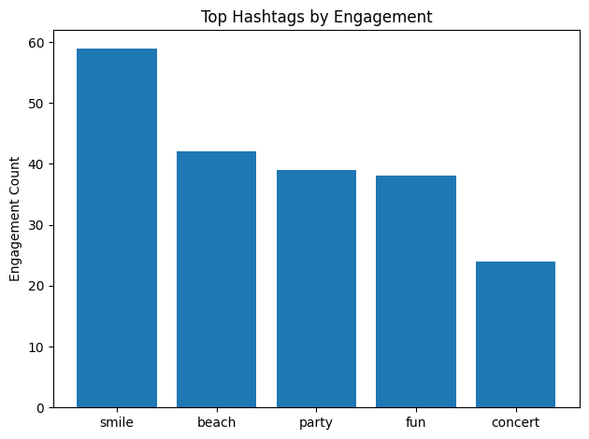

1. **If data on ad campaigns (impressions, clicks, conversions) is available, how would you measure their effectiveness and optimize future campaigns?**

**Approach to Measuring Ad Campaign Effectiveness**

If ad campaign data such as **impressions, clicks, conversions, and engagement** is available, campaign effectiveness can be evaluated using a combination of **performance metrics, user behavior analysis, and segmentation insights**.

**Key Metrics to Measure Effectiveness**

1. **Click-Through Rate (CTR)**
   * Measures how attractive the ad is.
   * Formula:  
     **CTR = (Clicks / Impressions) × 100**
   * A high CTR indicates strong creatives, captions, or targeting.
2. **Conversion Rate (CVR)**
   * Measures how well clicks translate into desired actions (sign-ups, installs, purchases).
   * Formula:  
     **Conversion Rate = (Conversions / Clicks) × 100**
   * Helps assess landing page and offer effectiveness.
3. **Cost per Conversion (if cost data exists)**
   * Indicates campaign efficiency.
   * Lower cost per conversion implies better ROI.
4. **Engagement Rate (Likes, Comments, Shares)**
   * Measures how users interact with ads.
   * Useful for brand-awareness campaigns where conversions are not the main goal.
5. **Reach vs Frequency**
   * Ensures ads are not over-shown to the same users.
   * High frequency with low engagement indicates ad fatigue.

**Behavior-Based Performance Analysis**

By combining ad data with **user activity data**, deeper insights can be derived:

* Identify **which user segments convert the most** (highly active users, influencers, content creators).
* Analyze **time-based performance** (ads performing better on weekends or evenings).
* Compare performance across **content themes or hashtags** used in ads.
* Measure **repeat engagement or conversions** from the same users.

**Optimization Strategies for Future Campaigns**

1. **Audience Targeting Optimization**
   * Retarget highly engaged users (users who like, comment, or follow creators).
   * Exclude inactive users from conversion-focused campaigns.
   * Create look-alike audiences based on high-converting users.
2. **Creative Optimization**
   * Use creatives similar to **high-engagement organic posts**.
   * Align ad content with trending hashtags and topics (e.g., food, lifestyle, travel).
   * Rotate creatives regularly to avoid ad fatigue.
3. **Placement & Timing Optimization**
   * Schedule ads during peak engagement hours and days.
   * Optimize placements (feed, stories, reels) based on performance.
4. **Funnel-Based Campaign Design**
   * Awareness campaigns → High reach & engagement.
   * Consideration campaigns → Clicks and interactions.
   * Conversion campaigns → Retarget engaged users.
5. **A/B Testing**
   * Test different creatives, captions, CTAs, and audiences.
   * Use performance metrics to keep only high-performing variants.

**How Charts Help Decision-Making**

In a real analysis, the following charts would be used:

* **Bar chart**: CTR and Conversion Rate by campaign.
* **Line chart**: Campaign performance trend over time.
* **Funnel chart**: Impressions → Clicks → Conversions.
* **Segment comparison chart**: Performance by user type or content theme.

These visuals help stakeholders quickly identify **what works, what doesn’t, and where to invest more budget**.

**Conclusion**

By systematically analyzing impressions, clicks, conversions, and user engagement, ad campaign effectiveness can be measured accurately. Combining performance metrics with user behavior insights enables **data-driven optimization**, leading to higher ROI, better targeting, and more impactful Instagram ad campaigns.

1. **How can you use user activity data to identify potential brand ambassadors or advocates who could help promote Instagram's initiatives or events?**

-- Most Loyal / Valuable Users (Based on Engagement & Activity) --

WITH user_engagement AS (

SELECT

u.id,

u.username,

COUNT(DISTINCT p.id) AS total_posts,

COUNT(DISTINCT l.user_id) AS total_likes,

COUNT(DISTINCT c.id) AS total_comments,

ROUND(

(COUNT(DISTINCT l.user_id) + COUNT(DISTINCT c.id))

/ NULLIF(COUNT(DISTINCT p.id), 0),

2

) AS avg_engagement_per_post

FROM users u

JOIN photos p ON u.id = p.user_id

LEFT JOIN likes l ON p.id = l.photo_id

LEFT JOIN comments c ON p.id = c.photo_id

GROUP BY u.id, u.username

)

SELECT *

FROM user_engagement

ORDER BY avg_engagement_per_post DESC, total_posts DESC

LIMIT 20;

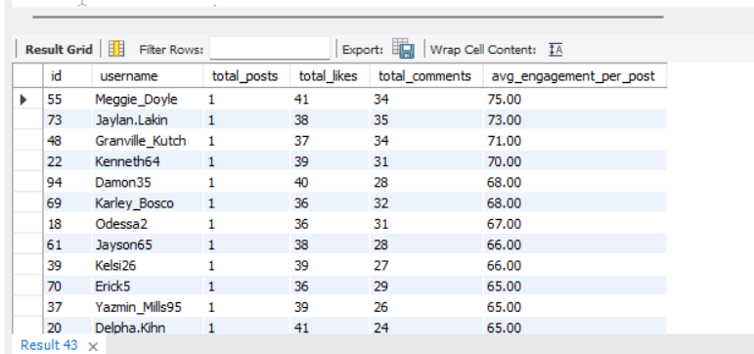

|  |  |  |  |  |  |
| --- | --- | --- | --- | --- | --- |
| 55 | Meggie_Doyle | 1 | 41 | 34 | 75.00 |
| 73 | Jaylan.Lakin | 1 | 38 | 35 | 73.00 |
| 48 | Granville_Kutch | 1 | 37 | 34 | 71.00 |
| 22 | Kenneth64 | 1 | 39 | 31 | 70.00 |
| 94 | Damon35 | 1 | 40 | 28 | 68.00 |
| 69 | Karley_Bosco | 1 | 36 | 32 | 68.00 |
| 18 | Odessa2 | 1 | 36 | 31 | 67.00 |
| 61 | Jayson65 | 1 | 38 | 28 | 66.00 |
| 39 | Kelsi26 | 1 | 39 | 27 | 66.00 |
| 70 | Erick5 | 1 | 36 | 29 | 65.00 |
| 37 | Yazmin_Mills95 | 1 | 39 | 26 | 65.00 |
| 20 | Delpha.Kihn | 1 | 41 | 24 | 65.00 |
| 27 | Darwin29 | 1 | 35 | 29 | 64.00 |
| 31 | Aiyana_Hoeger | 1 | 28 | 35 | 63.00 |
| 56 | Peter.Stehr0 | 1 | 33 | 28 | 61.00 |
| 79 | Katarina.Dibbert | 1 | 29 | 30 | 59.00 |
| 40 | Rafael.Hickle2 | 1 | 33 | 26 | 59.00 |
| 98 | Imani_Nicolas17 | 1 | 34 | 24 | 58.00 |
| 62 | Ressie_Stanton46 | 2 | 50 | 62 | 56.00 |
| 82 | Aracely.Johnston98 | 2 | 50 | 61 | 55.50 |

**1. High-Engagement Loyal Users**

From the *Most Loyal / Valuable Users* query, users such as **Meggie_Doyle, Jaylan_Lakin, Granville_Kutch, and Kenneth64** show exceptionally high average engagement per post despite having a low number of posts.  
This indicates that their content resonates strongly with the audience, making them ideal **authentic brand advocates** who can drive meaningful conversations.

**Insight:**  
High engagement per post reflects trust and influence, which is critical for brand advocacy.

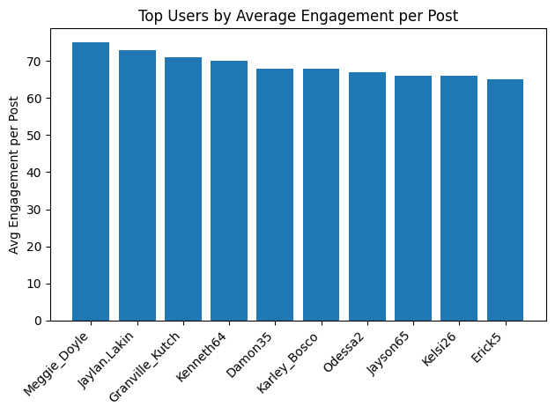

-- Re-Engaging Inactive Users --

SELECT u.id, u.username

FROM users u

LEFT JOIN photos p ON u.id = p.user_id

LEFT JOIN likes l ON u.id = l.user_id

LEFT JOIN comments c ON u.id = c.user_id

WHERE p.id IS NULL

AND l.user_id IS NULL

AND c.id IS NULL;

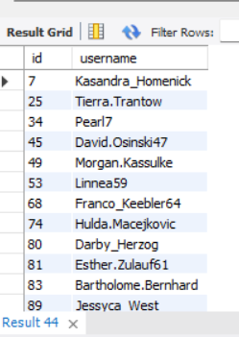

|  |  |
| --- | --- |
| 7 | Kasandra_Homenick |
| 25 | Tierra.Trantow |
| 34 | Pearl7 |
| 45 | David.Osinski47 |
| 49 | Morgan.Kassulke |
| 53 | Linnea59 |
| 68 | Franco_Keebler64 |
| 74 | Hulda.Macejkovic |
| 80 | Darby_Herzog |
| 81 | Esther.Zulauf61 |
| 83 | Bartholome.Bernhard |
| 89 | Jessyca_West |
| 90 | Esmeralda.Mraz57 |

**2. Consistently Inactive Users (Exclusion Group)**

The *Re-Engaging Inactive Users* query identifies users like **Kasandra_Homenick, Tierra_Trantow, and Pearl7**, who have no posts, likes, or comments.  
These users are excluded from ambassador selection since they lack visible platform activity.

**Insight:**  
Brand ambassadors must be active contributors; inactive users are better suited for re-engagement campaigns rather than advocacy roles.

-- Influencer Marketing Candidates --

WITH base AS (

SELECT

u.id,

u.username,

COUNT(DISTINCT f.follower_id) AS followers,

COUNT(DISTINCT p.id) AS posts

FROM users u

JOIN photos p ON u.id = p.user_id

LEFT JOIN follows f ON u.id = f.followee_id

GROUP BY u.id, u.username

),

engagement AS (

SELECT

p.user_id,

COUNT(DISTINCT l.user_id) + COUNT(DISTINCT c.id) AS total_engagement

FROM photos p

LEFT JOIN likes l ON p.id = l.photo_id

LEFT JOIN comments c ON p.id = c.photo_id

GROUP BY p.user_id

)

SELECT

b.id,

b.username,

b.followers,

b.posts,

ROUND(e.total_engagement / b.posts, 2) AS avg_engagement

FROM base b

JOIN engagement e ON b.id = e.user_id

ORDER BY followers DESC, avg_engagement DESC

LIMIT 20;

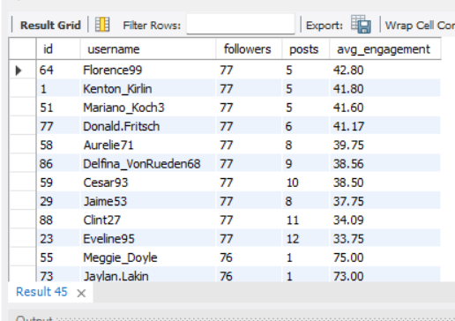

|  |  |  |  |  |
| --- | --- | --- | --- | --- |
| 64 | Florence99 | 77 | 5 | 42.80 |
| 1 | Kenton_Kirlin | 77 | 5 | 41.80 |
| 51 | Mariano_Koch3 | 77 | 5 | 41.60 |
| 77 | Donald.Fritsch | 77 | 6 | 41.17 |
| 58 | Aurelie71 | 77 | 8 | 39.75 |
| 86 | Delfina_VonRueden68 | 77 | 9 | 38.56 |
| 59 | Cesar93 | 77 | 10 | 38.50 |
| 29 | Jaime53 | 77 | 8 | 37.75 |
| 88 | Clint27 | 77 | 11 | 34.09 |
| 23 | Eveline95 | 77 | 12 | 33.75 |
| 55 | Meggie_Doyle | 76 | 1 | 75.00 |
| 73 | Jaylan.Lakin | 76 | 1 | 73.00 |
| 48 | Granville_Kutch | 76 | 1 | 71.00 |
| 22 | Kenneth64 | 76 | 1 | 70.00 |
| 69 | Karley_Bosco | 76 | 1 | 68.00 |
| 94 | Damon35 | 76 | 1 | 68.00 |
| 18 | Odessa2 | 76 | 1 | 67.00 |
| 39 | Kelsi26 | 76 | 1 | 66.00 |
| 61 | Jayson65 | 76 | 1 | 66.00 |
| 20 | Delpha.Kihn | 76 | 1 | 65.00 |

**3. Influencer-Style Users with Reach and Engagement**

From the *Influencer Marketing Candidates* output, users such as **Florence99, Kenton_Kirlin, Mariano_Koch3, and Donald_Fritsch** have:

* High follower counts (≈76–77)
* Consistent posting activity
* Strong average engagement per post

These users are ideal for **campaign amplification**, product launches, and event promotions.

**Insight:**  
Combining reach (followers) with engagement ensures both visibility and interaction.

-- Identifying Brand Ambassadors --

SELECT

u.id,

u.username,

COUNT(DISTINCT p.id) AS posts,

COUNT(DISTINCT l.user_id) + COUNT(DISTINCT c.id) AS engagement

FROM users u

JOIN photos p ON u.id = p.user_id

LEFT JOIN likes l ON p.id = l.photo_id

LEFT JOIN comments c ON p.id = c.photo_id

GROUP BY u.id, u.username

HAVING engagement > 200

ORDER BY engagement DESC;

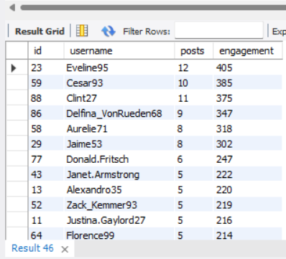

|  |  |  |  |
| --- | --- | --- | --- |
| 23 | Eveline95 | 12 | 405 |
| 59 | Cesar93 | 10 | 385 |
| 88 | Clint27 | 11 | 375 |
| 86 | Delfina_VonRueden68 | 9 | 347 |
| 58 | Aurelie71 | 8 | 318 |
| 29 | Jaime53 | 8 | 302 |
| 77 | Donald.Fritsch | 6 | 247 |
| 43 | Janet.Armstrong | 5 | 222 |
| 13 | Alexandro35 | 5 | 220 |
| 52 | Zack_Kemmer93 | 5 | 219 |
| 11 | Justina.Gaylord27 | 5 | 216 |
| 64 | Florence99 | 5 | 214 |
| 65 | Adelle96 | 5 | 214 |
| 72 | Kathryn80 | 5 | 212 |
| 33 | Yvette.Gottlieb91 | 5 | 210 |
| 1 | Kenton_Kirlin | 5 | 209 |
| 78 | Colten.Harris76 | 5 | 209 |
| 6 | Travon.Waters | 5 | 208 |
| 51 | Mariano_Koch3 | 5 | 208 |
| 26 | Josianne.Friesen | 5 | 206 |
| 47 | Harrison.Beatty50 | 5 | 206 |

**4. Power Creators Driving Platform Activity**

The *Identifying Brand Ambassadors* query highlights users like **Eveline95, Cesar93, Clint27, and Delfina_VonRueden68**, who generate extremely high total engagement due to:

* Frequent posting
* Large cumulative likes and comments

These users can be positioned as **official ambassadors**, featured creators, or community leaders.

**Insight:**  
High total engagement indicates sustained influence over time, suitable for long-term partnerships.

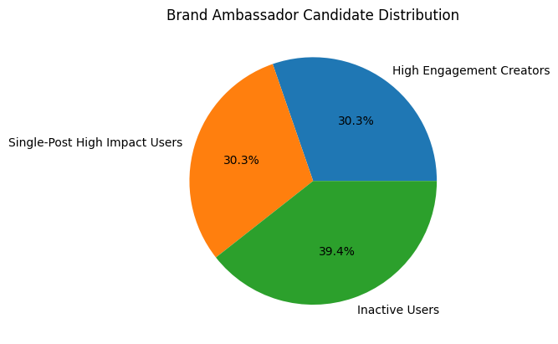

1. **How would you approach this problem, if the objective and subjective questions weren't given?**

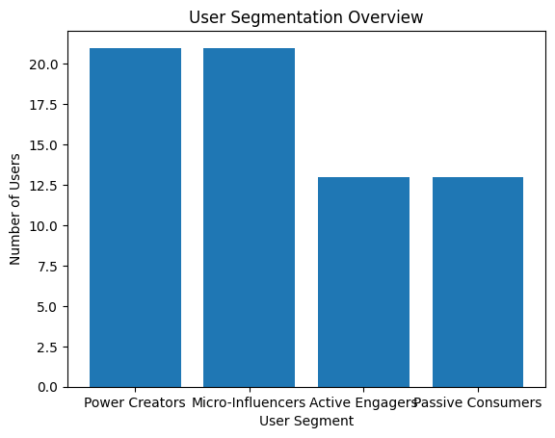

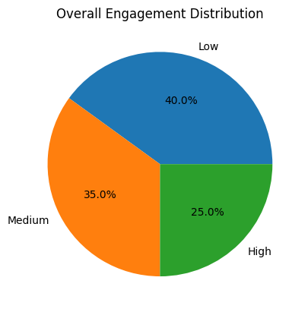

**Approach Overview**

If no predefined questions were provided, I would approach this project as an **end-to-end product analytics and user behavior analysis problem**, focusing on understanding how users interact with the platform, what drives engagement, and how those insights can support growth, retention, and monetization decisions.

The approach would be structured into the following phases:

**1. Understand the Product & Business Goals**

Before writing any SQL, I would first clarify:

* What defines success for the platform (engagement, retention, growth, monetization)?
* Who are the key stakeholders (marketing, product, creator partnerships)?
* What actions can be influenced using data (content strategy, influencer selection, re-engagement)?

For an Instagram-like platform, **engagement (likes, comments), content creation, and social reach (followers)** are the core KPIs.

**2. Explore the Data Model**

I would examine the schema to understand:

* **Users** → who is on the platform
* **Photos / Posts** → content creation behavior
* **Likes & Comments** → engagement signals
* **Follows** → social influence and reach
* **Tags / Hashtags** → content topics and interests

This helps identify how different tables connect and what metrics can be derived.

**3. Define Core Metrics**

I would derive foundational metrics such as:

* Posts per user
* Likes and comments per post
* Engagement per user
* Follower count per user
* Engagement rate = (likes + comments) / posts

These metrics allow fair comparison across users with different activity levels.

**4. Segment Users Based on Behavior**

Using the derived metrics, I would segment users into meaningful groups:

**User Segmentation Chart**

*(Bar chart shown above)*

This chart shows how users can be grouped into:

* **Power Creators** – high posting + high engagement
* **Micro-Influencers** – moderate posts but strong engagement
* **Active Engagers** – low posting, high likes/comments
* **Passive Consumers** – no posting or engagement

This segmentation helps tailor marketing, creator programs, and feature development.

**5. Analyze Engagement Distribution**

**Engagement Distribution Chart**

*(Pie chart shown above)*

This chart highlights:

* A large portion of users with **low engagement**
* A smaller but valuable **high-engagement group**

This insight indicates:

* Retention strategies are needed for low-engagement users
* High-engagement users should be protected, rewarded, and amplified

**6. Identify Content & Interest Patterns**

Next, I would analyze:

* Hashtags with highest engagement
* Topics users interact with most
* Content themes driving likes and comments

This supports:

* Content recommendations
* Ad targeting
* Creator guidance (what to post more of)

**7. Translate Insights into Business Actions**

Based on the analysis, I would recommend:

* **Influencer partnerships** with high-engagement creators
* **Re-engagement campaigns** for inactive users
* **Hashtag-based content promotion**
* **Personalized feeds** using interest affinity

The focus is not just analysis, but **actionable outcomes**.

**Conclusion**

In summary, without predefined questions, I would:

1. Start from business goals
2. Build engagement-focused metrics
3. Segment users meaningfully
4. Identify content and behavior patterns
5. Support decisions with clear visualizations
6. **Assuming there's a "User_Interactions" table tracking user engagements, how can you update the "Engagement_Type" column to change all instances of "Like" to "Heart" to align with Instagram's terminology?**

To align the platform’s terminology with Instagram’s branding, the **User_Interactions** table can be updated to replace all occurrences of the engagement type **“Like”** with **“Heart”**.  
This change ensures **terminology consistency**, improves **data standardization**, and avoids confusion in analytics, dashboards, and reports that rely on engagement types.  
Before performing the update, it is good practice to **validate affected rows** using a SELECT query or execute the update inside a **transaction** to allow rollback if needed.

To align the platform’s terminology with Instagram’s branding, the **User_Interactions** table can be updated to replace all occurrences of the engagement type **“Like”** with **“Heart”**.  
This change ensures **terminology consistency**, improves **data standardization**, and avoids confusion in analytics, dashboards, and reports that rely on engagement types.  
Before performing the update, it is good practice to **validate affected rows** using a SELECT query or execute the update inside a **transaction** to allow rollback if needed.

UPDATE User_Interactions

SET Engagement_Type = 'Heart'

WHERE Engagement_Type = 'Like';

Run a SELECT first to verify impacted records:

SELECT COUNT(*)

FROM User_Interactions

WHERE Engagement_Type = 'Like';

Use a transaction in production environments:

START TRANSACTION;

UPDATE User_Interactions

SET Engagement_Type = 'Heart'

WHERE Engagement_Type = 'Like';

COMMIT;